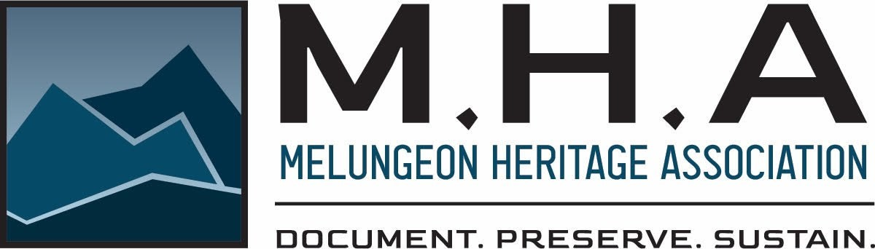
28th MHA Union—June, 21-22 2024—Hillsborough, NC
In collaboration with Indigenous Memories organization.
Location: The Whitted Building 300 West Tryon St, Hillsborough, NC 27278.
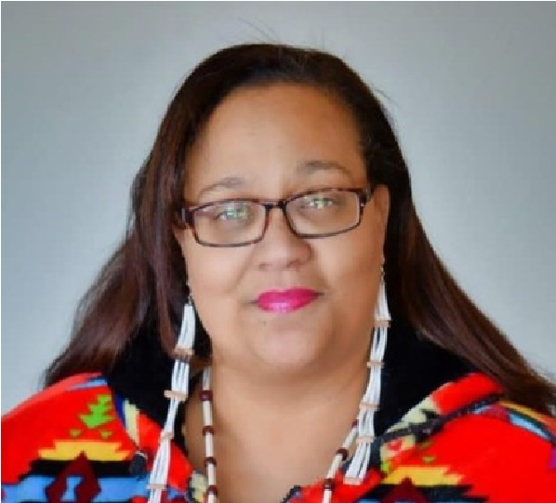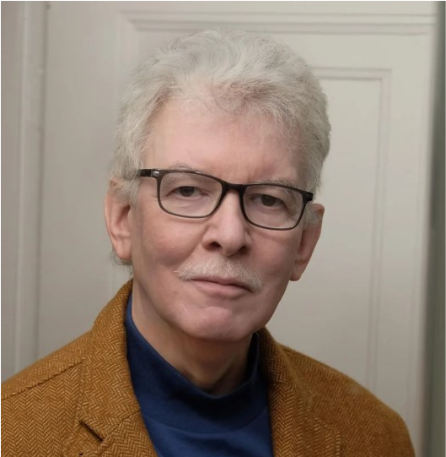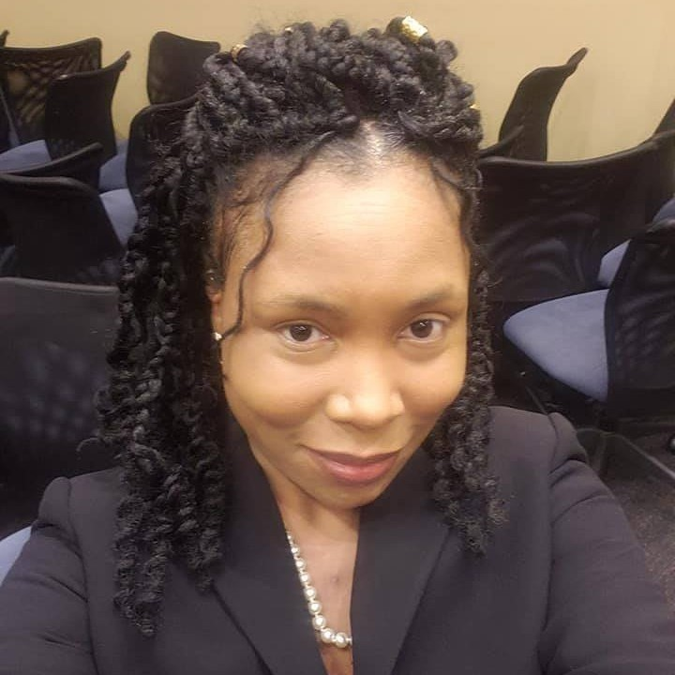
Dr. Crystal Cavalier-Keck | Marvin Tupper  Jones | Dr. Kimberly  Cheek
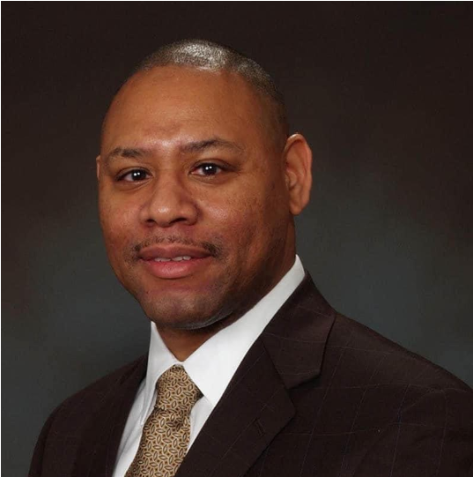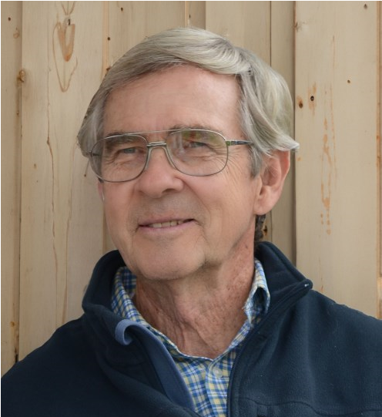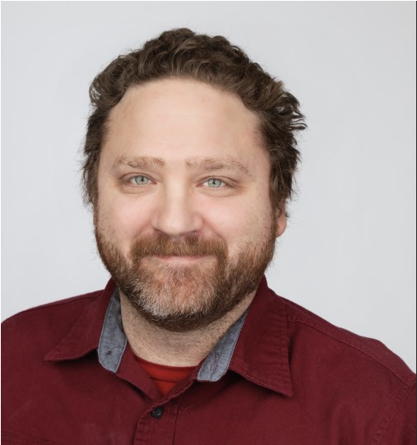
John King | Dr. Arwin  Smallwood | Nelson Dalton
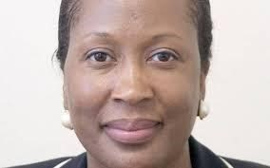
Judge Beverly
Scarlett

