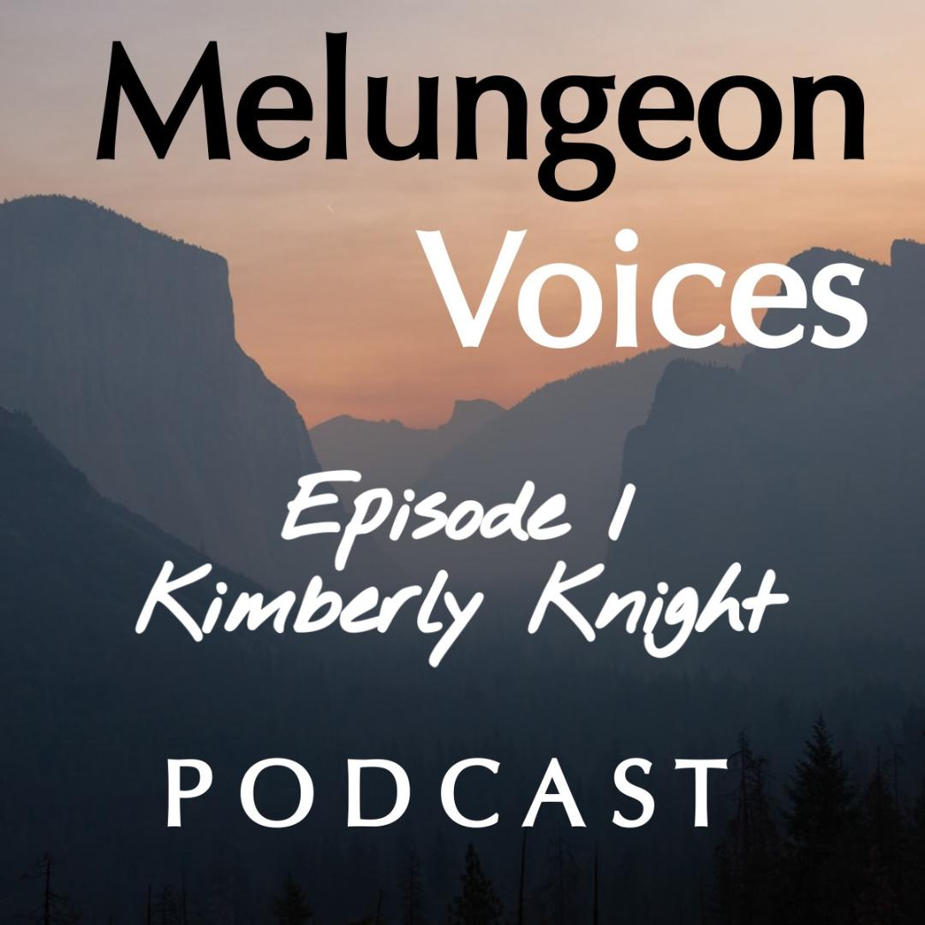

**Season Two Episode One Transcript**

Lis Malone:

Welcome to the Melungeon Voices podcast. Presented by the Melungeon Heritage Association. My name is Lis Malone and I am so proud to welcome you guys and everyone out there to season two of the Melungeon Voices podcast. And of course, I am here with the presidents of the Melungeon Heritage Association, Heather Andolina. Heather, it is so wonderful to see you in person.

Heather Andolina:

Yes, Lis. I am so glad to be back and with you.

Lis Malone:

We are both vaccinated.

Heather Andolina:

Yes.

Lis Malone:

And this is our first recording for the debut of season two and we're in a studio together, which is awesome. Amazing.

Heather Andolina:

Yes.

Lis Malone:

I can see her pretty smiling face. And of course, since this is the debut of season two, Heather would like to address the membership. And Heather, I'm going to turn it over to you.

Heather Andolina:

Yes. Thank you, Lis. Welcome back everyone to the Melungeon Voices podcast. Last year's debut season of our podcast was so well received that Lis and I are back for season two. This brand-new season brings with it all new guests and all new compelling content. Once again, we'd like to thank the Melungeon Heritage Association and its executive board and our members for their continued support in helping make this podcast series possible. Membership dues and donations directly fund this podcast. So, if you're not currently a member and would like to join, we would love to have you. Or if you'd like to make a donation to the MHA, we would greatly appreciate your support. Please visit us on the web at www.melungeon.org. to learn more.

Lis Malone:

Well, thank you Heather for that wonderful address for everyone in welcoming everyone to this new season of the podcast. So, for this week's episode, you had a fascinating conversation with Kimberly Knight. So why don't you fill everyone in on who she is and what we can expect from this week's discussion?

Heather Andolina:

Yes. Thank you, Lis. Kimberly Knight earned a back bachelors in family and consumer sciences and masters in social work. She is the founder and editor of The Lux Blog NC and is the committee chair of the advisory council for the first Black Indians NC Powwow for the state of North Carolina. She is currently co-directing and co-producing the upcoming documentary "Duality: A collection of Afro Indigenous Perspectives." In this season's debut episode, Kimberly and I discuss her Afro-Indigenous roots, her cultural identity and her latest endeavor in teaching others about her unique ancestry through film.

Lis Malone:

Well, that's great. Let's all take a listen.

Heather Andolina:

Kimberly. It is an absolute pleasure to have you with us on the debut of season two of the Melungeon Voices podcast.

Kimberly Knight:

Thank you so much. I'm so happy to be here.

Heather Andolina:

I'm so glad you're here too. How did you first learn about your Afro-indigenous ancestry?

Kimberly Knight:

Oh, wow. Let's start from the beginning. I was about five years old and my parents were traveling to Cherokee, North Carolina. My father was telling me all this history as we were driving up, because back then they did not have all the expressways they have now, so it was a really long trip. Almost literally half a day.

Heather Andolina:

Oh man.

Kimberly Knight:

I get there and I see all these beautiful people that look like my dad and they are speaking to him in this specific language and then he starts really telling me about this is the language of the people that live here and these are the Eastern Band Cherokee of North Carolina. And these people are people that are from my birthright. He starts going into telling me about his family history and the history of my grandfather, my paternal grandfather and everything.

Kimberly Knight:

It really gives this basis of him wanting me to have this knowledge base about this particular tribe. I found that very fascinating. And then on the flip side of the coin is my grandmother whose family lineage is from the ivory coast of West Africa. So, learning about African traditions was very important in my maternal side of my family of knowing both your native and African ancestry. And at that time, the most popular term to identify yourself was a Black Indian. It started there at age five, and then it just kind of at different steps. As I got older, the content of the books I was reading to the materials, all of that evolved, and then participating in powwows. For those listeners who may not know what a powwow is. It's a traditional Native American style festival, where you may see dance, music vendors. Being at to participate in all these different variety of events and going to tribal communities was amazing in my childhood.

Heather Andolina:

I noticed you mentioned Cherokee. Are there any other indigenous nations that are within your ancestry?

Kimberly Knight:

Yes. Since researching my family tree, we have found from my paternal side, the Eastern Band Cherokee. On my mother's side, we have had found ancestry to the Haliwa-Saponi tribe, which is in Eastern North Carolina. Halifax, Warren County area. Also, to the Tuscarora tribe, which has been in Bertie County. And also you've seen in Lumberton area in North Carolina. My mother's family lineage has been kind of more diverse. We've seen African American lineage, Native American lineage, as well as European, specifically British for her family.

Heather Andolina:

Excellent. All of those, the Saponi, Tuscarora and Cherokee are all associated with the Melungeon people. I myself have heard, we were told we had of course Cherokee in our family, but of course I've discovered it's so much more. Saponi and Tuscarora as well.

Kimberly Knight:

Nice. I'm loving all this new history I'm learning about your people because I've been very excited to learn about it through my newfound cousin, Frederick Murphy. So very excited about that.

Heather Andolina:

Well, you know Kimberly, Frederick and I share a common ancestor too. Maybe we all might be cousins.

Kimberly Knight:

I know. The more the merrier. We're going to have to look into that offline.

Heather Andolina:

Exactly. Yes, we will. Okay. Tell us a little bit about Black Indians NC and what served as inspiration for its creation?

Kimberly Knight:

Yeah. So Black Indians NC really pulls at my heartstrings because, even though I was learning all this amazing history and culture and everything as a child, I did not always see people that looked like myself. Or identified as I identified at that time. And so, I wanted to create a safe space for people who shared both ancestors of African American and Native American ancestors and talk about that out loud and be proud and excited about that.

Kimberly Knight:

With that being said, I decided to create Black Indians NC. We are in the process of becoming a nonprofit. We started out as a social media platform that really took off. When I realized, wow, this is really going somewhere, I needed to make sure I put some more roots into it. That's when I decided for it to become a nonprofit as well as hosting a annual powwow festival, which we will be hosting. But the real big piece I'd like to say for the inspiration of this has been my parents for sure. My late mother [inaudible 00:08:14] Knight and my father Rudolph Knight, these two amazing people made sure in my childhood that I was integrated with knowledge about who and where my people come from. And that inspired me. I really wanted to do these years ago, but now I actually have time.

Heather Andolina:

You know, Kimberly, going back to when you mentioned your parents and how you learned very early on about your Afro-Indigenous roots. I think that is just wonderful because with me, with my family, we didn't know. I didn't know until just a few years ago. It makes such a difference when you know about it very early on and you know the importance.

Kimberly Knight:

Absolutely. I think that no matter what age you are coming into that knowledge, I think it's just important to try to pass that tradition on to the rest of your relatives and friends and family, because that way it can start earlier on for more relatives and friends. And it'll be an opportunity for some really good dialogue about family discussion and history. So, yeah, absolutely. I'm glad that you did get to learning. You're doing amazing work. I'm super excited about the works that you do.

Heather Andolina:

Aw, thank you, you too. Right back at ya.

Kimberly Knight:

Thank you. Yeah.

Heather Andolina:

So of course, you mentioned earlier the powwow and the month the Black Indians NC will be having the first powwow event. What is the event's significance and how can people participate?

Kimberly Knight:

Yes. So, the significance of this powwow is it's the first Black Indians focused powwow in the state of North Carolina. That means that this is the first time you're going to attend a powwow festival that is the intersection very specifically about people of African American and Native American ancestry. That will be seen through drum groups, music, culture, food, all of the things that you see at a traditional Native American powwow, but you'll also see the African presence there as well. I really am excited about that part because it's so groundbreaking. We do have some really great surprises coming up for you at the event. For people wanting to get involved, they can definitely reach out to us. I can definitely provide my email and information for us today on the show to be able to let people know if they want to get involved. And they also could come out to the event and all those great things. So yeah, we're really excited about it.

Heather Andolina:

That's wonderful Kimberly. And at the end of this podcast, we'll make sure to get that information out to everybody. Let's get into your documentary "Duality: A collection of Afro-Indigenous Perspectives," which you are co-directing and co-producing with our good friend and cousin and season one podcast guest Frederick Murphy. How did you guys come up with the idea for this documentary?

Kimberly Knight:

In May, 2021, it was a year that Frederick and I had met. We met virtually on a panel and this panel was hosted by the Afro-American Resource Cultural Center and a young man by the name of Steven [00:11:23] there. He's a PhD student and he introduced us virtually and he was telling us about our interests and things in African Americans and Native Americans. We were on this awesome panel and we decided to stay connected. And as we were talking, we realized we had shared ancestors and shared areas where our people were from. Then we got into these really, really awesome, cool conversations about family and knowledge. Then he was telling me about his career as a documentarian and then we came to the conclusion that we should do a film. Ah, that's it. We should do a film about Afro-Indigenous people and all of these concepts, because when we connected, we both had so many different people we already knew who would be amazing to be in this film. That's how it really started and that led to the very beginnings of "Duality" coming together.

Heather Andolina:

Oh, wow. That is so awesome. You and I, by the way, we need to share GEDmatch numbers.

Kimberly Knight:

Yes, we definitely will. We must. We must. Yes.

Heather Andolina:

We just mentioned about, we should share our GEDmatch numbers Kimberly, but maybe we should tell our listeners what a GEDmatch number is.

Kimberly Knight:

Oh yeah, absolutely. So, a GEDmatch, everyone, is this website where you can upload your ancestry.com or 23andMe or my heritage DNA. It's a website where you can upload your ancestry points from there, and then it will give you a whole other set of matches of people that match to you as a possible relative. Now, GEDmatch can be a little bit intimidating. I must admit.

Heather Andolina:

Yes.

Kimberly Knight:

When I first got in there and Heather, you could probably count to this, that when I first got in there, I had to watch a few little YouTube videos and things to figure some things out. But it does give you a nice list of people to let you know and it gives you their contact info so you can connect. There are also ancestor groups in there that are specific based on sometimes it's an ethnic background or sometimes it's a population area. There's lots of ways to connect with people on GEDmatch. It's just another stream and it's at no cost to you, another stream platform where you can upload your information from Ancestry and other sites that you use for DNA to get more matches.

Heather Andolina:

With the film, what is the film's significance at this time?

Kimberly Knight:

Okay. For the significance of "Duality," I think the real core importance of is representation. Because a lot of times we don't get to see people who are identifying as Afro-Indigenous tell their true authentic stories. For Frederick and I, yeah, Frederick and I really wanted people to feel authentic through storytelling and talking about their ancestors, showing images of their ancestors and showing their pride and identifying as an Afro-Indigenous person. We really haven't seen films or content that really allowed the everyday person to really say what my life is like living as a present-day Afro-Indigenous person and what that looks like to keep tradition going. That's the real big significance is the representation.

Heather Andolina:

That is awesome, Kimberly. And I totally agree with you. And have you learned anything new since you started filming the documentary?

Kimberly Knight:

Yes. I have learned about 60 new cousins since I started this documentary and I've had the time to talk to them and they were people that some of them I've already known from across Indian country through the community, or they're people that I've attended powwow with. And some have been people that I've met along the way through college and graduate school, and then next thing you know, were sharing GEDmatch numbers, Ancestry, all these different resource tools and we find out that we are actually connected ancestrally and then we realize that's why we get along so well.

Heather Andolina:

Yep. Yep.

Kimberly Knight:

Yep. So, that's where we found that connection space. That was one thing that I definitely learned. And then learning the documentary process itself about filming and treatment plans, just all these really awesome things that filmmakers do and being out on set and casting and all these wonderful things, learned that as well. It's been a very eye-opening experience for me professionally and for my family research as well.

Heather Andolina:

Okay, Kimberly. I, myself am of course a filmmaker as well. My brothers and I are doing a documentary on our Melungeon ancestry, our African, Indigenous, and European ancestry. From filmmaker to filmmaker, what have been some challenges for you on this project?

Kimberly Knight:

Oh, yes. And I'm so excited about your project coming out as well. Very excited about that. For me, challenges were when we started filming, it was in 2020, the height of the pandemic. That was where it was really a scary time because we were trying to keep everyone safe, but also let people feel comfortable enough to authentically tell their stories and be unmasked in an open space where they felt comfortable and not possibly health wise compromised with a deadly pandemic going on. That was one challenge for sure. And two I'll say is just making sure you're casting the people that you know are going to do well on camera. I think most filmmakers can relate to that, because sometimes people can have a wonderful story and have everything together, but projecting that on film and it coming across authentically to the viewer, that can be a challenge itself. I learned about those things for sure during this process. For sure.

Heather Andolina:

I would completely agree with you, Kimberly. Because of the pandemic, we had to shut down our production last year and it took almost the whole year. It's only been within the last, I'd say three to four months, that we've gotten back into filming and getting back into everything. I'm there with you. What have been your biggest surprises while you've been filming?

Kimberly Knight:

I think my biggest surprises was seeing the participants really come to life with their stories. That has been really a beautiful surprise to hear about their life stories and things like that privately has been wonderful, but to see them just open up on film and be very comfortable and authentic and really telling their truths, that was great. And to see the advocacy work they're doing outside of the film and the things they're doing that is pushing forward the momentum of Afro-Indigenous people. I love it and those are one of the most beautiful surprises to me about this process. And also, just the fact that I'm getting to live something I've always wanted to do. As someone who also has been and a writer and a blogger, this is really awesome to be able to now transcend into film. I think this will definitely not be my first one. It will be many more to come.

Heather Andolina:

And I'm looking forward to all of them.

Kimberly Knight:

Thank you. Thank you. And yours too. Yes. Yes. Yes.

Heather Andolina:

Well, Kimberly, I just want to thank you so much for speaking with us today. It was wonderful to learn all about the. Black Indians NC organization. And please tell our listeners how they can learn more about Black Indians NC and the documentary film.

Kimberly Knight:

Absolutely. Thank you so much for having me today. It has been a pleasure. To all of you out there that are listening in, you can follow us on Instagram and Facebook @BlackIndiansNC. Also, if you want to send us an email, you can email us at blackindiandsnc@gmail.com. We would love for you to attend the powwow. It will be coming up, so we are very excited for it. It will be on September 25th and we are very excited for you to participate. If you want to learn more information about Black Indians NC, feel free to reach out to us.

Heather Andolina:

Excellent. And you know what? I'm going to be there at the powwow. I'm going to be there.

Kimberly Knight:

Yes. We would love for you to be there. And then for the film, please check us out. We will be on that same content wave of Black Indians NC or History Before Us. Or, you can also follow Cherokees for Black Indian History Preservation Foundation. All of us are on Facebook or Instagram and that's where you can see some behind the scenes clips of "Duality." We also have on our YouTube pages History Before Us and The Lux Blog NC. You can see the actual trailer that's up there now and that's live for everyone. But fall 2022 is when we're expecting to have this film released and we can't wait for everyone to see it.

Heather Andolina:

That is awesome. I've been following you on social media and so I've seen the trailer and I'm super excited. I can't wait.

Kimberly Knight:

Thank you. Thank you so much.

Lis Malone:

You've been listening to the Melungeon Voices podcast. On behalf of myself, Heather Andolina and the entire MHA Executive Committee, we'd like to thank all of those who participated in this episode possible. For more information, you can visit them on the web at melungeon.org. That's M E L U N G E O N. O R G. The information views and opinions expressed in this podcast episode do not necessarily represent those of the MHA. Melungeon Voices is presented by the Melungeon Heritage Association. All rights are reserved.