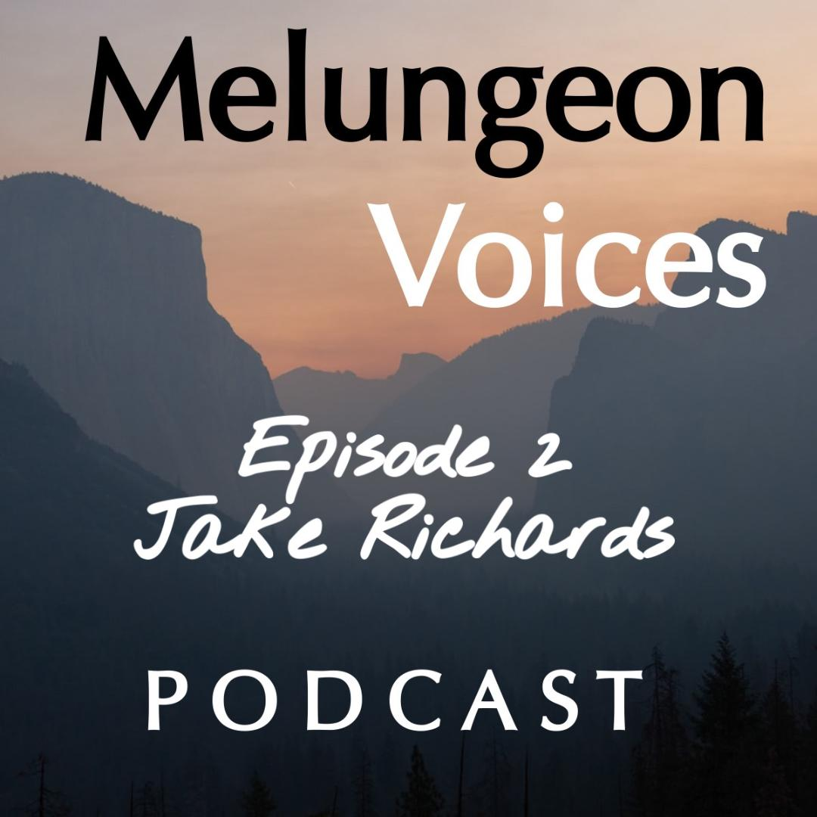

**Season Two Episode Two Transcripts**

Liz Malone:

Welcome to Melungeon Voices presented by the Melungeon Heritage Association. My name is Liz Malone and I'm joined by my usual partner in crime, the president of the Melungeon Heritage Association, Heather Andolina. Heather, how are you today?

Heather Andolina:

I am doing very well. How are you, Liz?

Liz Malone:

I'm wonderful. Again, awesome to be in the studio with you.

Heather Andolina:

Yes, face-to-face.

Liz Malone:

So, for this week's episode, Heather, you had a very intriguing conversation with Jake Richards. I personally was very curious to hear what he had to say based on just reading about his description and what the subject matter would be. So, why don't you fill us in a little bit about Jake and what your conversation entailed?

Heather Andolina:

Sure thing, Liz. Jake Richards grew up and currently lives in east Tennessee. He is the author of two books, one published just a few months ago. Jake writes about his Melungeon and Cherokee traditions and ancestry, which are on both sides of his family. His Melungeon ancestors came from both Newman's

Ridge and the Pee Dee River migrations. In this episode, Jake shares his fascinating knowledge of Appalachian folklore and magic, as well as some interesting spiritual traditions connected to the Melungeon people.

Liz Malone:

That's awesome, let's take a listen.

Heather Andolina:

All right, well, I liked to welcome to the Melungeon Voices Podcast, Jake Richards. Hi Jake.

Jake Richards:

Hey, how are you?

Heather Andolina:

I'm fine. How are you?

Jake Richards:

I'm doing good.

Heather Andolina:

All right, well, let's get into it. So, would you share with us a bit about your Cherokee upbringing and what it was like?

Jake Richards:

Well, it's a little bit confusing, because my father's side has always been extremely adamant that we were always Cherokee, even though it wasn't technically enrolled or anything like that, so they were always adamant to take me to the local powwows, tell me the stories and everything like that. My mother's side of the family, they kind of backed it up as well, even though they only said that, my Mammaw Sadie, they would only say that she was half Indian and that her father was full-blooded Indian, but they only ever said Indian and it wasn't ever like tribe specific, which I always thought was kind of weird. So, like from the very beginning or whatever, where I was always confused as being Hispanic or anything like that, that was the only thing that I had to, I don't know, I guess, like lay claim to that was my identity, if that makes sense.

Heather Andolina:

Yes. Yes. You know, and it's interesting because we too, my grandmother was told, we had Cherokee. So, the same with us. So how did you first learn about your Melungeon ancestry?

Jake Richards:

Well, I mean my family, well, my mother's family, not my father's family has always been like big on the spiritual, like Appalachian beliefs and dreaming true, like gifts and things like that. Well, it happened, I don't even know how many years ago, but it was a long time ago. I started having these recurring dreams of, I was in like a dark forest somewhere and there was a bonfire or something going on and there was a bunch to people around it, but there was one man who was standing in front of me, kind of like a silhouette or something like that. And he kept shaking me by my arm, by my shoulders saying, find us, find us, over and over. And I had that dream over and over for like, I think like six months.

And then finally I was like, you know what, I'm going to look into this whole Cherokee story to try and figure it out. So that's when I started looking through ancestry.com and everything. And I was checking role after role and I wasn't finding any names. I wasn't finding anything that would document their

Cherokee claims. Because they always said that they came from somewhere near Raleigh, North

Carolina, but documentation wise, I can't trace them outside of Sullivan, Tennessee. It only goes back to I think, 1830 on that line, but it kept confusing me because I kept seeing all these people who were at one census marked as white, another census marked as mixed or another census marked as black. And it always varied between the different family members.

So, like one family member would consistently be marked as white, another one, theirs would change all the time. So, I was like, okay, so what am I doing wrong here? And then, the same thing happened with my mother's line. I could only take it back to my fourth great grandfather, Tennessee Evens. And it was just a dead end from there. So that's really how it happened for me, I guess. And then I don't remember exactly when I started thinking that it was possibly Melungeon or anything like that, but I know that I heard the word Melungeon from my father years ago, there was this song that used to play on the radio back in like 2005. It was like early 2000s and it was talking about being a red bone and it apparently said the word Melungeon.

I don't remember the word Melungeon because my daddy used to sing it whenever we were driving in his truck that he had at the time. It was a S10 Chevy or something like that. And how, I don't know if this will make sense, but whenever he would sing it, he would like enunciate like the red bone part, so that's like what stuck with me in my head. But I don't remember him saying Melungeon part of the song. So, I mean, I think for me it was a pretty easy like switch identity wise, if that makes sense. Because my whole life people have always asked, what are you? Or are you Hispanic or whatever? And before then, all I knew how to say was, just Cherokee because that's all I had ever been told. But then once I figured that out, I was, it just didn't feel right to keep like claiming Cherokee, even though I had no documentation or whatever. So, it was a pretty easy like move from Cherokee to Melungeon.

Heather Andolina:

Right, right. So, you briefly mentioned it, but we're going to go into it. Your primary areas of research are on Appalachian folk lore and folk magic.

Jake Richards:

Yes.

Heather Andolina:

What is the significance of each, both folklore and folk magic?

Jake Richards:

Well, folklore is basically like the, to me, it's the makeup of a people's story. So, it's made up of like their history where they come from, what has occurred, how tight it is with the land. And whereas the folk magic is sort of the byproduct of the folklore. It is the meeting point between religion and medicine. And it's fueled by the necessities that the daily life back then called for, whether it was making sure that the crops grew in or making sure that somebody who just got a cold or whatever, didn't die because of it. Because you know, one death could decimate an entire family, especially if they were like one of the people bringing bread into the home.

Heather Andolina:

So how has your unique Cherokee and Melungeon ancestry influenced your study and practice of Appalachian folk magic?

Jake Richards:

Well, I mean with my father's side of the family always tell me the Cherokee stories and take me to powwows combined with my mother's Baptist family. I mean it kind of melts together kind of easily because my mother's side of the family, theirs wasn't like a by the book type of Christianity. It was more like a day by day. I guess I would call it and a lot more like animistic and fluid rather than like just stagnant. So, it’s kind of like paired to get other pretty easily in the development of my mind.

Heather Andolina:

Now, how do you feel Appalachian folk magic differs from other forms of folk magic?

Jake Richards:

Well, first and foremost, because of its makeup through the history of the people who came into the region, whether it was a Scotch, Irish, the British, French, German, so on and so forth. And you know how that kind of melded together with local Cherokee practices as well as African American practices.

Heather Andolina:

We're going to talk a little more about your books later, but when you just mentioned about the European African and indigenous in your books, you discussed the intersections between European, African and indigenous traditions that led to a unique Appalachian tradition. Can you expand on this?

Jake Richards:

Yeah, well in, well the way, the best way comparison that I can explain it in is, you have deep south Hudu, which is primarily African American folk magic from like Louisiana, New Orleans, that type of area. The biggest difference is again through its history and the folklore who that influenced it because down in Louisiana you had different native tribes influencing it as well as a hefty amount of French influence as well. Whereas in Appalachia, the majority of the influence came from the Scotch Irish and the Cherokee and, and then that leads further into the differing histories of each region in relation to the slave trade, because down in Louisiana, the region was majority Catholic. So, they were easily able to hide their practices or whatever, or within the Catholic church.

So that's why you see a lot of works with the saints, as a, kind of like a mask for the LAOA, especially in Louisiana voodoo, whereas in Appalachia, the biggest religious belief was just like protesting in Baptist, I think a little bit of Methodist. So, there wasn't much room for those African American practices to be passed down, because in Appalachia, anything that was, they basically believed that anything the black man did was of the devil, as we can even see in one of the Melungeon myths where Melungeon’s are said to be the children of the devil. So, I mean, it's like in Appalachia history took a different route, most of the remnants of African American belief that can be found in Appalachian folk magic within [inaudible

00:11:40] magic. And I don't think there's an actual term for it, but it's like the array of outdoor decorations, like a bunch of statues and oh, bird baths, that type of thing as well as grave decorating.

Heather Andolina:

And you know, I'm glad you mentioned, I was going to mention about, because I've run across it in my research about the Melungeon people were mythologized as boogeymen. People would tell their children that the Melungeon’s were going to come and get them. I was going to ask you if you had come across any of that and-

Jake Richards:

Oh yeah. I mean, Appalachian folk magic, just like anything else in America had, was not left untouched by racism or exoticism. Because there was, there's a lot of old recipes that call for certain things simply based on the amount of melanin in a person's skin. And we can see the same apply to Melungeon’s with the belief that if you went into Melungeon territory and you didn't get dogs or anything sicked on you, then within a couple of days, you may waste away from an unknown disease. Which everywhere else in the south was called unnatural illness, which was like a magical illness that was, it was basically like a curse to make you waste away, like from the waist up or anything like that.

Heather Andolina:

Oh wow. All right, Jake, let's discuss your published books Backwoods Witchcraft, Conjure and Folk Magic from Appalachia and your most recent, Doctoring the Devil: Notebooks of an Appalachian Conjure Man, please give us an overview of each title.

Jake Richards:

Well, Backwoods Witchcraft basically introduces you to the actual practice of the region while also explaining how the practice is rooted in not only geography of the region itself, but also the biodiversity that can be found in the region, in both plants and animals and how within the mountainous regions of Southern Appalachia, how the mountains shaped and molded not only history, but also the cores of individual people's lives. Because I mean the mountains, they affect our weather, they basically the weather. It's like a little basin and you'll have like little micro climates here and there. On one side of the mountain, it'll always mostly be sunny, a little bit rainy. Whereas on the other side it's always cloudy and foggy and everything at that. And then that further expands into how Appalachia, which was called the Endless Forest during the first days of colonization, it’s kind of, it not only stoked like praise in like the beauty of creation, but it also stoked fear in the unknown. Because you had panthers, wolves, all kinds of things back then before they went extinct.

So that just furthered man's fear of the unknown, which furthered the folklore stories that they would tell about the region or whatever they saw in the woods or whatever they thought they saw peeking at them from behind the tree.

Heather Andolina:

So, can you share some common Appalachian folk traditions with us?

Jake Richards:

Well, there are a few recipes throughout Appalachia that are, what I would say are the extremely, like they're the most common throughout the entire region. And those are usually recipes for stopping the flow of blood, usually with a Bible verse. But sometimes with just like the swiping of a hand over the wound. I think I even found one recipe where the person doctoring the other person is to just blow on it and then the blood stops. And then the others were like wart charming, whether it was buying someone's wart from them, using a shiny dime, a piece of potato, a piece of bacon, a string, a thorn. They literally used anything that they had, whether it was prick in the wart, rub in the wart, tie the wart off as well as measuring rights. Which is basically where like, if a child has asthma, you would take him to somebody who had the gift and they would take a stick, sometimes the stick is specified to be like Sourwood Birch, Willow, something like that.

And they would cut it the same length of the child or the same height rather. And then they would measure the child with the stick and then they would either throw the stick in the woods or hide it up in like the rafters of the cabin or in an attic somewhere. And it was said that once the child outgrew the measurement of the stick, then they would likewise outgrow the asthma or whatever else, whatever other ailment they were being doctored for.

Heather Andolina:

Jake, I have heard of the wart charming by the way, in my family, yes. So, are there any that are specific to Melungeon’s that you know of?

Jake Richards:

Well, the only ones that I've come across really is throwing a silver coin into a newborn baby's, I believe it's their first bath will ensure good luck in their first years. And then a tradition of always putting tobacco on the riverbank when you're fishing, so that the river spirits don't follow you home and try to steal the fish back. And then of course the one in reference to Melungeon grave houses is about a spirit that would slip into the grave and disturb the dead. But it seems that piece of folklore is so old that the rest of it's been forgotten, like what kind of spirit, why would it do that? Or any other information like that? You know, Melungeon, they were, I mean, their culture was like majority Appalachian as well.

So, you would see the same works among them as you would in greater Anglo Appalachia. So, they still followed the same little quirky rights of like measuring blood stopping, wart charming. And you can even see it in writings, if they can be believed, where she was offered a necklace or a necklace of blood beads, which reminds me of a red corn necklace that I was handed down that was supposed to be for nose bleeds.

Heather Andolina:

So, Jake, the red corn beads, is that connected to the Cherokee traditions or indigenous traditions?

Jake Richards:

Not that I have found.

Heather Andolina:

Okay.

Jake Richards:

And I actually talk about it in Backwoods. I mean, it's like the, I don't know how they did it. It was like, I guess they soaked the corn kernels first or something like that, but they're like sewn onto like, just like little brittle sewing thread. So, so I mean, it's basically about to fall apart.

Heather Andolina:

That's fascinating. I had not heard of that one. Okay. I'm sure that our listeners would love to learn more. Where can they purchase your books? And do you have a website and social media accounts they can follow?

Jake Richards:

Yeah. They can find it on amazon.com or at their local Barnes and Noble, or just on the Barnes and Noble website. And they can also follow me on Instagram and Facebook.

Heather Andolina:

Excellent. All right. Well, Jake, we want to thank you so much for joining us today on the Melungeon Voices Podcast. And it was great talking to you.

Jake Richards:

Thank you.

Liz Malone:

You've been listening to the Melungeon Voices Podcast on behalf of myself, Heather and Alina, and the entire MHA executive committee, we'd like to thank all of those who participated in making this episode possible. For more information, you can visit them on the web at Melungeon.org, that's M E L U N G E O N . O R G. The information, views and opinions expressed in this podcast episode do not necessarily represent those of the MHA. Melungeon Voices is presented by the Melungeon Heritage Association. All rights are reserved.