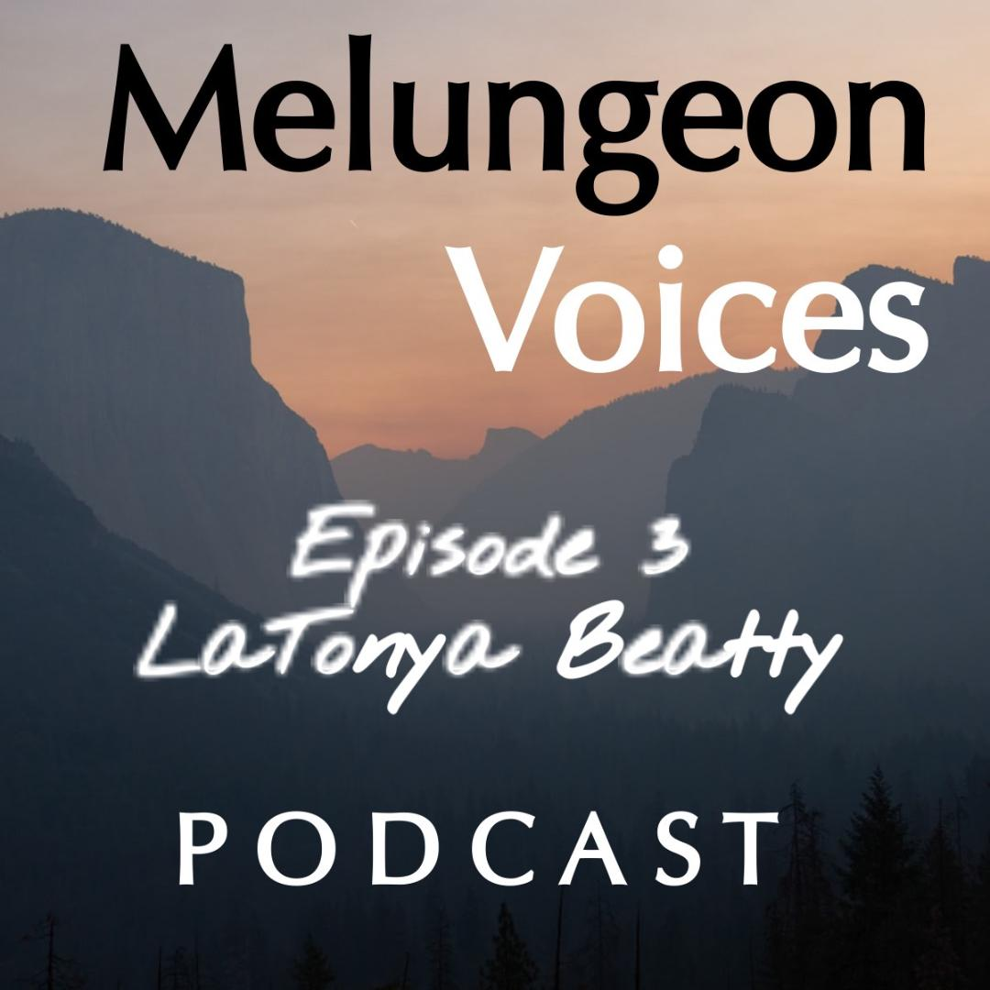

**Season Two Episode Three Transcript**

Lis:

Welcome to the Melungeon Voices podcast presented by the Melungeon Heritage Association. My name is Lis Malone and as always, I'm joined by Heather Andolina, the current president of the Melungeon Heritage Association. Heather, it's wonderful to see you again today.

Heather:

Yes, we're seeing an awful lot of each other Lis.

Lis:

Oh my gosh, we're going to get sick of each other.

Heather:

Never.

Lis:

Heather has the most infectious giggle that as just demonstrated. So, while we're recording these episodes, sometimes it's a little challenging to get through sessions because the giggle fits are pretty frequent, I would say, right?

Heather:

Yes. A lot. Yes.

Lis:

So, in this week's episode, you had a very informative discussion with LaTonya Beatty. So I guess without the giggles, why don't you share with everybody a little bit about LaTonya and what we can expect?

Heather:

All right. Thanks, Liz. LaTonya Beatty is an avid genealogist, blogger and family historian. She has been researching genealogy for almost 20 years. She holds an associate’s degree in art and is the author of two books and is currently working on a new children's book. In today's podcast, Tonya shares, little known facts about the Quakers, the underground railroad, and free people of color.

Lis:

That sounds great. Let's listen in.

Heather:

I am so pleased to welcome LaTonya Beatty to the Melungeon Voices Podcast. Hi Tonya.

LaTonya:

Well, good evening. How are you?

Heather:

I am fine. How are you?

LaTonya:

I am doing great. Thanks for having me on.

Heather:

All right. Let's get into it. We would love it if you would share a bit about your multiethnic background.

LaTonya:

Yes. So, I am of many, many different amalgamations, tribes and ethnicities. I descend from Croton, Saponi, Georgia, Cherokee, Okani. I'm also of African, Portuguese, French, Scottish, German, and Irish descent. So, the fabric of America.

Heather:

Love it. So, let's discuss your research on Quakerism, which is also known as the Religious Society of Friends. What are the origins of this society?

LaTonya:

Yeah, so this organization was founded and led by George Fox in 1650 in England. It all started because at the time they were going through religious turmoil and religious persecution. George Fox decided to lead the religious movement.

Heather:

Okay. So how was the first American colony for Quakers established?

LaTonya:

Okay. So, the colony was established by a man named William Penn and he was also from England. His father petitioned James, the Duke of York to protect William from the English laws of the religious persecution. So, in exchange for that, since his father passed away, the king, King James II, decided to grant William Penn land. 45,000 acres in the new world. And it was a debt to his father who was an ally of King Charles II and served the crown during the English and Dutch war.

So, William Penn basically wanted a colony populated with Quakers, and the idea was called the Holy Experiment. Living basically, it was like a utopia to where they were able to live and be governed according to their faith.

Heather:

Okay, so can you share some insights into their beliefs and who was eligible to be a Quaker and why?

LaTonya:

Yeah, so basically anyone could be a Quaker. They welcomed Muslims, you could be a Buddhist, a Jew, any ethnic background. And as a matter of fact, there's a quote by George Fox and he wrote, God who made all pours out His spirit upon all men and women in the world. In the days of his new covenant, yes upon white and blacks, Moors and Turks and Indians, Christians, Jews and Gentile. That all with the Spirit of God, might know God and the things of God and serve and worship in spirit and in truth. So that pretty much is self-explanatory of how diverse they were and accepting of everyone.

LaTonya:

It's amazing with history and genealogy, a lot of things that they've omitted from school that you learn just by doing research in family genealogy. So, I thought that was very interesting as well.

Heather:

Were any Quakers influential in the first abolitionist document against slavery?

LaTonya:

Yes, so basically Francis Daniel Pastorius was the founder of Germantown, which that's where my German ancestors were also from, just wanted to add that in there. He started running things in the absence of William Penn. Unfortunately, William Penn had to go back to England to dispute a land claim by a gentleman who claimed Pennsylvania. So that was the reason for William Penn returning back to England to settle that dispute.

LaTonya:

So basically, things got out of hand in Philadelphia and there were more non-Quakers in that settlement and things started getting out of hand. People started owning slaves, and that was pretty much against... Well William Penn, unfortunately he did own several slaves. So, I just wanted to reiterate some Quakers at the time did own slaves, but the beliefs were pretty much against that. And I'll get into that later on during the episode.

LaTonya:

So basically, so Francis Daniel Pastorius, he was German. He was from Germantown. He started running things and he was the founder of Germantown. And he insisted that slavery was evil and that enslaving people based on race was not Christian. So, Francis then recruited fellow German immigrants to sign the Germantown Quaker Petition against slavery in 1688. And it was the first abolitionist document in North America. And I thought that was incredible.

LaTonya:

And then you have other abolitionists by the name of John Woolman, who organized boycotts of products made by slave labor and was responsible for convincing many Quaker communities to publicly denounced slavery. Others included Lakree Shamat and Elizabeth Cady Stanton, who also helped with the underground railroad and the women's movement. So, some very outstanding people in history.

Heather:

Okay, so what part did Quakers play in helping to free people of color from slavery?

LaTonya:

Very prominent people like Levi and Catherine Coffin. They did a lot for slaves and free people of color.

They were also abolitionists and they were involved in the underground railroad. They moved from North Carolina to Newport, Indiana because they opposed slavery. And a lot of the Quakers did. And they offered their home to fugitive slaves and said to have aided around 2000 to 3000 fugitive slaves.

LaTonya:

Remarkably, none of them were ever caught and returned to slavery. So that was one couple that helped free people of color and also slaves. And also, Quakers founded schools for blacks and people of color. Unlike other places, Quakers allowed blacks to attend their schools. And they taught them how to read and write.

Heather:

Wow, I have heard of Levi Coffin actually.

LaTonya:

Yes, yes.

Heather:

Yes, yeah. I am familiar with him. Yeah.

LaTonya:

Very influential person.

Heather:

So wasn't Levi Coffin, the unofficial conductor of the underground railroad, I think, is what they called him or something or like...

LaTonya:

Yes. Yes. So that was basically the epic center, the main station, the central station of the underground railroad. And they used their house to harbor slaves. There's a national historic landmark that was erected 1966 in their honor. And it's located in Fountain City, Wayne County Indiana. So, they played a pivotal role in helping the slaves to their freedom.

Heather:

I got to go check that out.

LaTonya:

Me too, that's on my bucket list for sure.

Heather:

Yes. Yes. We'll go up there together. Girl’s trip.

LaTonya:

Oh yes, sounds like a plan. Definitely.

Heather:

Okay. Tonya, can you explain to our listeners what the Manumission Society Constitution declared?

LaTonya:

So, I wanted to add as far as how the Quakers also helped slaves and free people of color, the Quakers also worked not only through their yearly meetings, but also organized, for example, a North Carolina Manumission Society. The stronghold of this society was in Gilford, Randolph and Chatham counties in North Carolina. There's a gentleman by the name of Charles Osborne, who was an anti-slavery preacher who attributed to the organization as well.

And the organization grew rapidly in the 1820s. By 1826, there were 23 branches with more than a thousand members in the counties of Gilford, Chatham, Orange, Davidson, Randolph, and Forsyth County.

Heather:

So, Tonya, can you explain to our listeners what the Manumission Society Constitution declared?

LaTonya:

Yes, so the constitution, and I will read an excerpt out of what it declared. The human race, however, varied in color are justly entitled to freedom and that it is the duty of nations, as well as individuals enjoying the blessings of freedom to remove this dishonor of Christian character from among them. But more especially, in these United States, where the principles of freedom are so highly professed.

Heather:

Wow. That's fascinating.

LaTonya:

Yeah. I agree. And also, the Manumission Society proceeded to do everything possible to free the slaves and to alleviate suffering among free people of color.

Heather:

So what leadership roles, if any, did women play within the Manumission society?

LaTonya:

Yes. So, women, they were basically the backbone. There were Female Manumission Societies, and they were organized in 1825, 5 of which were in existence in 1827. It had about 40 branches. Yes, before it declined in the early part of the next decade. The organization was primarily interested in the emancipation of slaves in North Carolina.

Heather:

Would it be safe to say that you yourself have Quaker ties within your own family history? And if so, would you please share that story with us?

LaTonya:

Yes, I'll be happy to. So basically, there was a family, the Latimore family, is one of the families that interacted with my free people of color, Brooks Cooper and Clark line that were in Western North Carolina. So, the Latimore’s were landowners in Western North Carolina. And they were mentioned as being Quakers. And one of the Latimore boys, for example, taught one of my Brooks ancestors, how to read and write. And they also became very good friends. And on another line, which is my Clemmons line, they migrated from Georgia to the foothills of the Blue Ridge Mountain.

And a man by the name of John Beam, granted my family land to build a primitive Baptist church. And the Beams were also said to be Quakers and at another section I read about the Beams, some of them were Melungeon as well. So, I thought that was very, very interesting and generous for someone to do that for my family. To grant them land.

Heather:

Yes. I have heard of the Primitive Baptist in connection with the Melungeon people.

LaTonya:

Yes, ma'am yes. And coincidentally, the name of the church is Indian Creek Primitive Baptist Church. So that pretty much lets or gives an indication that there were natives around. And that's also the oral tradition of that side of my family as well. And to add to some more of my family history, I have another line, which is my Beatty line. They also interacted with Quakers.

And in a section of the Badey family book, it reads John was a blustery little fellow with a strong set of lungs. Irresponsible on one end and responsible on the other, for lots of noise for want of attention. When wanting to be sad, or just rocked in the little Quaker made cradle given to Sarah for one of her earlier children. While religious freedom played an important part in the migration, equally was the lust for the adventure and to get away from the crowded conditions of their homeland. Continuous wars and the increase in burden of taxation, the industrious and thrifty of these adventurous folks first settled in Philadelphia, Pennsylvania.

Governed by the Quaker William Penn later because of that, most of the best land had been taken by earlier settlers of the colony. A group decided to push westward over the Blue Ridge Mountains into North Carolina. These folks later were called the Pennsylvania Dutch. And I descend from these people.

Heather:

Now Tonya, your family moved down into the Blue Ridge Mountains, correct?

LaTonya:

Yes. Correct.

Heather:

Okay, did they stay there in North Carolina, did they ever move into Tennessee by chance?

LaTonya:

Now, Tennessee, there is mention of some of the Beatty’s traveling to Tennessee. I did converse with one of my relatives that I found coincidentally on the DNA site. And he did mention that we had some relatives to branch off into Tennessee and also some of them went to Ohio to live among a black and Jewish community, but I'm not that familiar with those lines. So that's something that I would like to further research.

Heather:

Okay. Interesting. Okay. I thought I remember when we had spoke previously that you had mentioned that.

LaTonya:

Yeah. So, there's also Jewish ties somewhere. So that just gives you a picture of how diverse these people were and how accepting the Quakers were. Because I have that experience in my own family.

Heather:

Now were the Quakers ever involved with maroon communities that you know of?

LaTonya:

We mentioned the underground railroad. I would like to also add that Native Americans were also a part of the underground railroad. So, it was not only the Quakers, there were native Americans that harbored slaves as well. So, you could say they were Maroons and they also were part of the underground railroad. So, I just wanted to put that out there, to not leave them out of history as well.

Heather:

Oh yeah, yeah. Were there any significant persons of color who were involved in Quakerism that you would like to mention?

LaTonya:

Yeah. So, one person that comes to mind is Hiram Rhodes Revels, he was the first Afro-American and Croton Indian US Senator. And he was born in 1820 in Statesville, North Carolina. He was the son of free parents of mixed Afro-American and Native American Croton ancestry. Revels moved with his family to Lincolnton, North Carolina, where my family was from in 1842 where he became a barber

Several years later, he left the south and enrolled at Beech Grove Seminary, a Quaker institution near Liberty, Indiana. From there, he moved to Mississippi. So, I thought that was really cool. I did not even know that about him.

Heather:

So, can you please tell our listeners now how they can learn more about you and your writing? Because you've published a couple books and right now, you're working on a children's book, right?

LaTonya:

Yes. So, I have two books that I've published. The first one is Where Life Has Taken Me: Compilation of

Poems From My Teenage Years into Adulthood. And if you want something, a little thriller type mystery,

I have a book of short stories called Vivid Dreams. And right now, I'm working on a children's book and I'm working with the illustrators. So once that comes out, I will definitely put that out there to let the audience know.

Heather:

That would be awesome. That would be great. Do you have a website or social media information, which you can provide for our listeners to get in touch with you?

LaTonya:

Yeah, so I have several pages of... But if they're interested in finding out more about my like genealogy and history in general, I have a blog. And it's The Pony Girl Blog, www.theponygirl and I should come up. And it has lots of information about my family, free people of color line who settled in the foothills of the Blue Ridge Mountains. My Portuguese Croton heritage, my ancestor that was involved in the Confederate Army.

LaTonya:

So, there's so much history in my own family that they do not teach you in school. And that's why I have so much passion. And also, I'm on Facebook, under Tonya Evans Beatty. And also, I have my massage therapy page. This is what I do for living. I'm a massage and body work therapist, and I'm also a voice over artist, narrator and poet. So, I have two of my books are also audio recorded. You can find them Apple Store, Walmart, Amazon. Yes. So yeah, very cool stuff.

Heather:

Oh my gosh. I have learned so much from our conversation. I didn't know a whole lot about the Quakers. So, this has been amazing. And Tonya, it has been an absolute pleasure having you on our podcast. And I just want to thank you so much.

LaTonya:

Oh, and thank you so much for allowing me to be a part of your podcast and I'm really appreciative of it. And thanks again for having me.

Lis:

You've been listening to the Melungeon Voices podcast. On behalf of myself, Heather Andolina and the entire MHA executive committee, we'd like to thank all of those who participated in making this episode possible. For more information, you can visit them on the web at Mullen.org. That's M-E-L-U-N-G-E-O-N dot O-R-G. The information, views and opinions expressed in this podcast episode do not necessarily represent those of the MHA. Melungeon Voices is presented by the Melungeon Heritage Association. All rights are reserved.