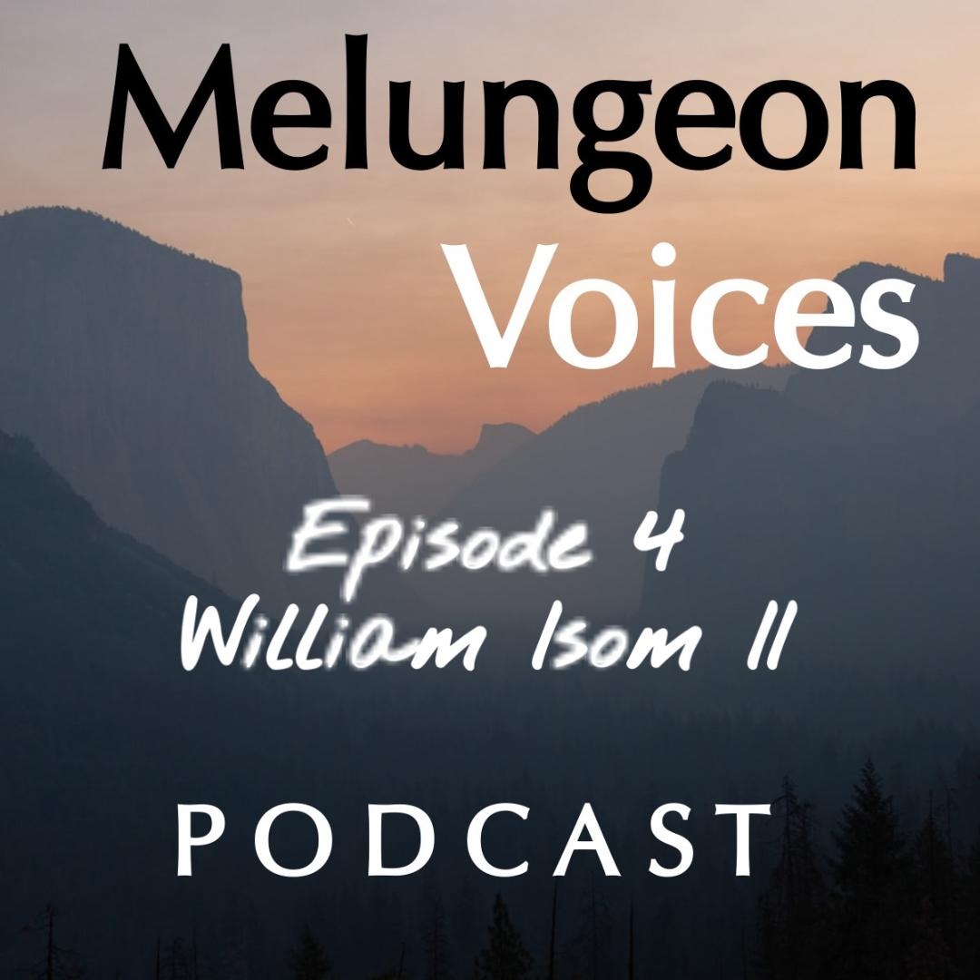

**Season Two Episode Four Transcript**

Lis Malone:

This is the Melungeon Voices podcast presented by the Melungeon Heritage Association. My name is Lis Malone and as always, I am joined by Heather Andolina, who is the sitting president of the Melungeon Heritage Association. Good day, Heather.

Heather Andolina:

Good day to you, Lis.

Lis Malone:

Awesome. Wonderful to be with you, as always.

Heather Andolina:

I know, really.

Lis Malone:

So, for this week, before we jump into this episode, we have an update about a season one alumni podcast guest, Paul Johnson.

Heather Andolina:

I am very excited to share an update on season one guest, Paul Johnson, who is currently editing a forthcoming anthology collection called "From the Roanoke to the Native American, African and European ancestors in community histories". He is collaborating with authors Marvin Tupper Jones, Julie Williams Dixon, William F. Cale, M.D, and Dr. Arwin Smallwood. We are excited for Paul and we look forward to reading the finished product.

Lis Malone:

Well, as you can tell, we only feature underachievers on the Melungeon Voices podcast, right?

Heather Andolina:

Exactly.

Lis Malone:

Well, congratulations, Paul. We want to send you our best and we wish you the best of luck and we can't wait.

Heather Andolina:

Exactly. Can't wait.

Lis Malone:

So, to get onto today's business at hand, we are in episode four.

Heather Andolina:

Yes.

Lis Malone:

Wow, this is the hump episode.

Heather Andolina:

Yes.

Lis Malone:

Wow.

Heather Andolina:

Halfway through.

Lis Malone:

So, this is hump week for season two, and this week you spoke with William Isom the Second. So, fill us all in about William and what you guys talked about.

Heather Andolina:

All right, thank you Lis. William Isom the Second is a native of Hamblen County, Tennessee. He's the director of community outreach for East Tennessee PBS and is the director of the Black In Appalachia project. In my conversation with William, he and I explore what it's like to be multiethnic and black in Appalachia, and how it inspired the growth of the Black In Appalachia project.

Lis Malone:

Sounds great. Let's take a listen.

Heather Andolina:

I'd like to welcome William Isom the Second to the Melungeon Voices podcast. Hi William.

William Isom II:

Hey Heather, how are you?

Heather Andolina:

I'm fine. How are you?

William Isom II:

I'm doing okay, I'm doing all right.

Heather Andolina:

All right. On this glorious Friday afternoon.

William Isom II:

Mm-hmm (affirmative).

Heather Andolina:

So, I'm going to start off with, tell us a bit about your ethnicity and what you know about your family's ancestry.

William Isom II:

Yeah, so my ethnicity or my family's ancestry, we all kind of came out of Southwest Virginia and upper East Tennessee. We've been around for at least about 200 and... about 250 years-ish. Somewhere around in there just, and have kind of stayed in the East Tennessee, Southwest Virginia area since that time. There's a swath from kind of Knoxville up to Wise County, Virginia and everything in between. So, my mom's side of the family is from Southwest Virginia primarily. Of course, she migrated down to East Tennessee and married my dad. She was a Hopkins, and a Beckner, and a Swindle and actually she's the... Yeah, she came out of Appalachia, Virginia, and so her family's been up there for a long time, but primarily identifies as white, but there's always those tales of the native American grandma, which may or may not be true.

And then there's my dad's side of the family was primarily descended from the offspring of slaves and slaveholders, enslaved people and slave holders, from kind of Scott County, Virginia down into Hawkins County and Grainger County, Tennessee. And yeah, so we kind of settled in what I like to call the "industrialized river valley" of East Tennessee, Hawkins and Hamblen Counties, down on the Holston and Nolichucky rivers where we farmed. And I grew up close to the Nolichucky River on the Hamblen County, Cocke County line. And that's kind of where I grew up at reaping and running the back roads of that area.

Heather Andolina:

My grandparents are from Northeastern Tennessee. Yeah.

William Isom II:

Oh.

Heather Andolina:

So, William, have you had your DNA tested? Have you done that?

William Isom II:

I have.

Heather Andolina:

Okay.

William Isom II:

I have had my DNA tested, yeah. By a couple of different entities. Yeah. Actually, the first DNA test that I ever got was Brent Kennedy mailed me one in the mail way back in the nineties. Somewhere my spit was part of that kind of debacle that went down, but yeah, that was my first experience with DNA. I never saw... I guess those results were kind of put into a bucket somewhere that nobody knows about, but that was my first experience. So, I didn't get any results from that, but I did Ancestry and 23andMe and National Geographic. It seems like... Yeah. The National Geographic one, the anthropology department in UT, a friend of mine wanted my genetic code for a secret experiment. I'm joking. That's not true, but they... Yeah, I think I'm mostly Scotch according to Ancestry, which is weird, because I always make fun of the whole Scotch Irish Appalachian thing. People love to talk about that, "Oh, we're Scotch Irish". It's like, "Yeah, well actually I'm stuck with mostly Scotch", which kind of poo poos my own joke so.

Heather Andolina:

I have a lot of Scottish and Irish as well.

William Isom II:

Mm-hmm (affirmative), yeah.

Heather Andolina:

So, going back to what you mentioned with Brent Kennedy sending you a DNA kit, is that when you first learned about the Melungeon people?

William Isom II:

No. I grew up hearing that term my whole life and just thought that that was something that... I thought that that's something that everybody knew about and didn't know that it was some kind of anomaly until I went off to college and realized that other people didn't know that word and weren't familiar with that word. So, I grew up hearing that my whole life in Hamblen County.

Heather Andolina:

So that's so interesting that you knew about the Melungeon people growing up. So, hearing the term "Melungeon", in what context and what did it mean to you?

William Isom II:

Yeah, I think at the time I really didn't think anything special about it. It was like saying somebody with red hair or somebody that's black or somebody that's whatever. And so, it wasn't really any kind of... I didn't think anything special about it and the ways that I had heard... I heard it all kinds of ways, but oftentimes it was to describe a family or describe an acquaintance or in between friendly people, but also, I have been called that as... I mean, that's kind of how the name works, right? Like you don't call yourself that, but other people call you that.

And so, you get called that when you're growing up and as a young person, but then also those were fighting words on... On Thompson Creek Road in Hamblen County, the white kids called you that like there was a fight, and so that was something... Or at Union Heights Elementary School on the playground, that was a fight. And so, it was the same as someone calling you a N word or something like that. So those are the kind of contexts that I grew up hearing that word. It was either in family settings and kind of like a descriptor, or an insult. And so, it was those kinds of ways.

Heather Andolina:

Right. I've always heard of it as a more of a discriminatory term.

William Isom II:

In public settings. In public settings it's usually a racial epithet. In family settings it was definitely not a racial epithet.

Heather Andolina:

Okay, gotcha. So, this actually brings me right into my next question. You are the founder of the Black In Appalachia project, and we're going to discuss that in just a moment, but I would first like to get your take on what your experience has been being black in Appalachia.

William Isom II:

Mm-hmm (affirmative). Yeah, I think that's a very big question. I mean, it's wonderful and beautiful and there's a very vibrant and thriving black community in East Tennessee and Southwest Virginia and Eastern Kentucky that hold on and care and take care of each other. And there's also town, right? There's also the cops and the kind of the bureaucracy associated with the courthouse and fines and fees and racism in town, mostly. What I've found, just as a kind of a simplistic answer to that... I have found and continue to find refuge in these rural communities where those things are less of an issue and you have to think less about your position as a black person in Appalachia.

I think that's personally, but I think generally, Appalachia is not unique. Appalachia sits in the South and the South sits in the United States of America and all the racism and terrible atrocities that occur in the United States of America occur in Appalachia too. And so, Appalachia's not unique in that regard. We all sit in the United States and I think more broadly, yeah, it's what is black life like in the United States for me.

Heather Andolina:

Now, from your childhood to today, do you feel that there have been significant changes in the Appalachian region for persons of color and of mixed ethnicity?

William Isom II:

Mm. I think since I've been a young person, and I don't know if... As you get older, your perspective on things changes and so I don't know if it's just me getting older or if actually things are shifting and changing, but certainly I'm the first generation of my family that never lived under kind of formalized Jim

Crow laws, right? Segregation. And so being the first generation of my family that never lived through Jim Crow, like formalized Jim Crow, I think those people who instituted those policies and that generation before me that suffered under those policies, are starting to retire and die now. And I think now I'm in my mid-forties and so I'm kind of stepping into different leadership roles in the region and dealing and engaging around policy stuff personally, and societal things and all the things that you do as a grown-ass man, right?

So it's like I am seeing, from my perspective, that now things have shifted primarily because the segregationists and the people that instituted these things are dying away, right? And so, I think that there's an opening now, and I know you're going to get into asking me some of the questions about Black In Appalachia, but I think there's an opening now and has been for a little while where just now we can talk about these stories that have happened in our community with our families. In that way, I think things have shifted significantly. And the young people, they've taken the mantle and they're running down the road with it. They want to figure out how to stay in the region and they don't want to leave, and they're rolling up their sleeves and doing the hard political work that our generation didn't do or were able to do.

And so, they've learned lessons from us and they're going down the road, and that gives me a lot of hope. And I think that those young people out in the streets in big stone gap Virginia and hazard Kentucky, and young people in Johnson City and in Morristown in the streets, I'm like, "Yeah, that generation gives me a lot of hope and I think things are shifting in a positive way".

Heather Andolina:

Yes, I would agree. Definitely. And that leads us right into, tell us about the Black In Appalachia project and how you see the Melungeon people fitting in.

William Isom II:

All right, okay. Similarly, that's a big question, but the Black In Appalachia project is also a big answer, a big fat answer. I'll try to keep it as succinct as possible. It's a project that started in 2002. So, we're coming up on 10 years next year, and the primary goal is to just document and make available as much black history in the Mountain South as we could possibly physically do, and make that freely available to the public. That's an easy answer. The longer answer is we produce short, locally specific documentaries very cheaply. My boss hates when I say that. It's a partnership with East Tennessee PBS, public television in Knoxville and universities, oftentimes different university departments, and residents. And so, it's often resident-led work and we provide a kind of infrastructure and resources and support for residents to be able to tell their own stories, whether that looks like a short, locally-specific documentary or cataloging and archiving materials that people keep in their homes or doing mapping work, GIS work around in and out migration of black folks. Scanning in school records and making those available and everything in between.

We don't go into any community without an invitation. Once a community invites us to come help them with something, then we dig in and work. And once we make that commitment, we're there for the duration, off and on forever. So, I can imagine... I mean, there may be a point where we pull out of a community and say, "Oh, we've did all that we can do", but it's always... It's a very dynamic kind of work, providing support oftentimes the archives, like local archives, or churches to bolster their ability to tell their own story themselves. Yeah. I don't know if that makes sense or not. I'm getting worse and worse at this as I get older. It's weird.

Heather Andolina:

No, I get it.

William Isom II:

Yeah.

Heather Andolina:

Yeah. And then how do you see the Melungeon people fitting into this?

William Isom II:

Oh. So yeah, I guess how I see Melungeon people fitting into Black In Appalachia work... It's kind of a touchy thing because there are Melungeon folks or Melungeon descended folks that absolutely do not want to be equated with black folks, right? They don't want to be black and they don't want to have African ancestry and they don't want that kind of stigma. And I think that there's reason for that, right? I mean, historic reasons why families absolutely like, "We made it this far. We're not black, we're not black. Okay. We're cool. We're safe", and they don't want to. So, it's a touchy subject, right? And so, I think that, that, and even understanding that kind of personal choice to self-identify is something that...

You can't negate people's agency in being able to self-identify, right?

But for me personally, I see... And just to kind of wheel back a little bit, number one, we don't engage with communities unless we've been invited in by community members, right?

Heather Andolina:

Mm-hmm (affirmative).

William Isom II:

And so, I will say, apart from Sneedville, Newman's Ridge, Lee County, Virginia kind of Melungeon populations and descended folks, I think that more broadly, people who may be equated with [inaudible 00:17:32]. and we do work with communities in Southeastern Ohio and Gallia County, Ohio, Lawrence County, Ohio, those families. Kind of East Jackson, Ohio. So, these historically mixed-race families that have, at different points of time, been classified as Melungeon by outside people, and that's always how the designation comes. It's always somebody from the outside saying, "You're a Melungeon". Then you're like, "(expletive) am I? (expletive), I guess I am". And we work with and have close ties to the Lumbee community, particularly in Baltimore and in East Tennessee. One of our board members is Lumbee for Black In Appalachia.

So, we have these ongoing working relationships with Lumbee community members and scholars, particularly Ashley Minner in Baltimore. And so we share tools on how we're mapping our communities, and I've learned a lot from Ashley's work, mapping what was called "the reservation" in Baltimore. I go up to Baltimore every year and go to the church homecoming up there, and so I think for the project, we lean on and work with these communities like the Holi Indians in Taswell County, Virginia, or Taswell, Virginia. All these different kinds of groups that are other historically mixed-race populations, and they're everywhere.

Heather Andolina:

Yeah.

William Isom II:

And I think that, understanding that out of emancipation, you had thousands of these mixed-race communities that coalesced, I think that helps inform our work and the way that we understand the base foundation for many of these communities across the South, and particularly Appalachia. Those mixed-race families provided kind of the base foundation coming out of the civil war for a lot of these communities and the economies that grew out of these communities.

William Isom II:

And those narratives laid the foundation for education and church development, cemeteries, and trade routes across state lines and county lines and family connections and networks. And so, to answer your question, how Melungeon’s fit in, I think Melungeon’s specifically, I love, and any chance I get to talk to Wayne Winkler or also Jack Goins I'll... When he used to be down at the archives in Hawkins County, me and him always shared information and he taught me a lot about researching, and so I'm always indebted to Jack Goins. And I think in developing this work politically, Darlene Wilson is still one of my... has been one of my mentors, and I go and visit her every chance that I get up in Wise County. And she helped me to develop politically, which also helps provide some of the framework in regards to the Black In Appalachia project. So, I think that those are kind of some ways that I see how Melungeon people intersect in and out of this Black In Appalachia work.

Heather Andolina:

I love it. And I know you've given me lots of research material since I've been doing my research on the Melungeon people. And thank you so much. It's great. It's great resources. Now, you mentioned your work at PBS. Has it in any way influenced you in your development of your Black In Appalachia project?

William Isom II:

My work at PBS has certainly influenced my work with Black In Appalachia, because... I think the biggest component has been understanding how you can produce documentaries in a really short, quick way and get materials and churn it out. So, I think that that discipline... Chris Smith is the Director of Production Development at East Tennessee PBS, and really has been my... I mean, he's technically my boss, but he's really been a really good friend in helping me, particularly early on in the creation and establishment of Black in Appalachia as a thing, and really... Like we did the first documentary. It was about price public... No, it was about Swift Memorial Institute, a late black college in Rogersville, Tennessee... That was once in Rogersville, Tennessee.

That was the first one that we did, and out of that, he said, "Oh, we saw the response from people", and he was like, "We should keep doing this", and I haven't looked back since. I was like, "Well, at some point he may jerk the rug out from under me, but in the meantime, I'm going to run like hell and get as much done as possible". So yeah, I think understanding the structure and timeline and deliverables that a station requires has been really beneficial to the project and how to interact with other PBS stations. We send stuff out to KET or North Carolina public television, and so understanding how to engage and interact with other public television stations and NPR stations has been really instrumental in the development of the Black In Appalachia project.

Heather Andolina:

That is fantastic. Well, William, you also have a podcast.

William Isom II:

Oh, my goodness.

Heather Andolina:

Yes. So please share some thoughts on what served as inspiration for starting the Black In Appalachia podcast and what can our listeners expect to learn?

William Isom II:

Oh, my goodness. This podcast is probably the best thing that's ever happened to Black In Appalachia. People love it. So, the Public Radio Exchange was offering to do podcast training and Chris Smith at PBS said, "Hey, what if we applied for a Black In Appalachia podcast?". And I said, "No way, I do not want to do a podcast". I was like, "I have enough stuff to do and I am absolutely...", and I was like, "If you want to do a podcast, I'll apply on behalf of the station. I'll send them all the things and you do the podcast, because I don't have time. I got enough to do. I'm not interested". So yeah, so he applied and then he was like, "Oh crap, we got approved as the only public television station to be included in the Public Radio Exchange training ever". So, all these others are like NPR people with their NPR chops and their NPR accents.

William Isom II:

And then one of only... I think there was three Southern stations also. So, he was like, "We got to prove, what do we do?", and I was like... I knew and had been talking to Dr. Ian Keshialamine, who's a sociologist at the University of Tennessee. We have been talking previously because her work has been around black Knoxville and so similarly in the context of Appalachia. I'm more like country bunk and... I like the country stuff. And so we had talked several times on trying to figure out how to work together and we had applied for some grants together, like National Endowment for the Humanities grants and stuff like that, which I won't talk smack about them.

So yeah, we had applied for different grants together and so I said, "Well, let me reach out to Ian". And I mentioned it and she was excited and so she was like, "I need a co-host". And so Angela Dennis had been... She's a journalist and she had been doing stuff, really kind of politically active work around incarceration and black lives matter with some different national media the outlets. I mean, kind of like Black With No Chaser and things like that. And so, we reached out to Angela and Angela said yes.

William Isom II:

And so, they had their team. There was Angela, Ian Keshi and Chris, and I was off the hook. So, they did an excellent job of producing this podcast and we did an episode on Melungeon’s... Or they did an episode on Melungeon’s talking to Wayne Winkler.

Heather Andolina:

Yes. I listened to that.

William Isom II:

Ah, Wayne Winkler's such a jewel, isn't he?

Heather Andolina:

Yes.

William Isom II:

Like he's got all the... We should bottle that guy and sell it. So, we've got an episode about guns in this second season. We've got an episode about drag performers, trans and LGBTQ performers. We're cooking on an Appalachian hip hop episode. We've also covered all kinds of stuff like Emancipation Day, Juneteenth and the 8th of August and yeah, all kinds of stuff. We're going to be talking about slavery and... Yeah, you name it.

Heather Andolina:

Yeah. Season two is fantastic. It's awesome. I've been listening to the episodes, so I very much encourage our listeners to listen to the Black In Appalachia podcast.

William Isom II:

Mm-hmm (affirmative).

Heather Andolina:

You're coming up on your 10-year anniversary in 2022. What do you see for the Black In Appalachia project for the next decade?

William Isom II:

That's a good question. So, we're looking at... I can kind of give you broad strokes. We're looking at getting into the telling of lynching stories in the Coalfields in upper East Tennessee, which are hard and terrible stories, but we're looking at those, developing those. Hopefully soon, we'll be done with... We've got three documentaries that we're working on. One about Knoxville College, which is a HBCU in Knoxville, Tennessee, and another one about the communities in South Eastern Ohio. We've been working on that for probably about four years, but COVID so. But we're really hoping to engage and kind of dig into Southern West Virginia in the coming years and coming up soon. And we're going to keep trying to provide support to community members.

I do foresee within the next... in not too long, that at some point, a younger person will take my place and I'll get to go back and just be the weird old man digging through records somewhere. And so just provide support, just be a somebody that shovels coal for the project instead of being out front so much. And so, I do anticipate very soon, within the next probably... potentially the next year or so that I will step down, because I don't think anybody should be leading an organization for 10 years. In my personal opinion, that's how things die. And so, I think that I'm very cognizant of that and terrified of founder syndrome, and so I'm certainly looking at how I can step back and help develop leadership from the next generation to drive the boat and do all kinds of weird things that I never thought of. And mess up and try again and do good things and yeah. So that's where I see the project going, at least in the next five years.

Heather Andolina:

Excellent. Well, I'm looking forward to it, to see what else Black In Appalachia project has coming.

William Isom II:

Yeah.

Heather Andolina:

So, keep it up, you're doing great.

William Isom II:

Thanks.

Heather Andolina:

And I'm sure our listeners would love to learn more about your work. What's the best way for them to find you on social media or on the web?

William Isom II:

Yeah. If people want to find all the things Black In Appalachia, they can go to blackinappalachia.org, Black In Appalachia dot O R G, and that's where we put all of our films and all of our research and photography projects, and the podcast, are all available on that website. Also, we're on Instagram as Black In Appalachia. We're on Facebook and we have a Twitter, but nobody... I mean, who has time? So, I mean, that's enough. And also, the younger people working on the project are like, "You should get a TikTok", and I was like, "You should murder me because I do not want to get a TikTok". So, at some point there may be a TikTok, but it'll be like me and that podcast. I won't do it, I'll refuse, and then it'll be a smashing success.

Heather Andolina:

But it has been such a pleasure speaking with you today, William, and I just want to thank you so much for being with us.

William Isom II:

Yeah. Thanks for having me and I look forward to the next union.

Lis Malone:

You've been listening to the Melungeon Voices podcast. On behalf of myself, Heather Andolina, and the entire MHA executive committee, we'd like to thank all of those who participated in making this episode possible. For more information, you can visit them on the web at melungeon.org. That's M E L U N G E O N dot O R G. The information, views and opinions expressed in this podcast episode do not necessarily represent those of the MHA. Melungeon Voices is presented by the Melungeon Heritage Association. All rights are reserved.