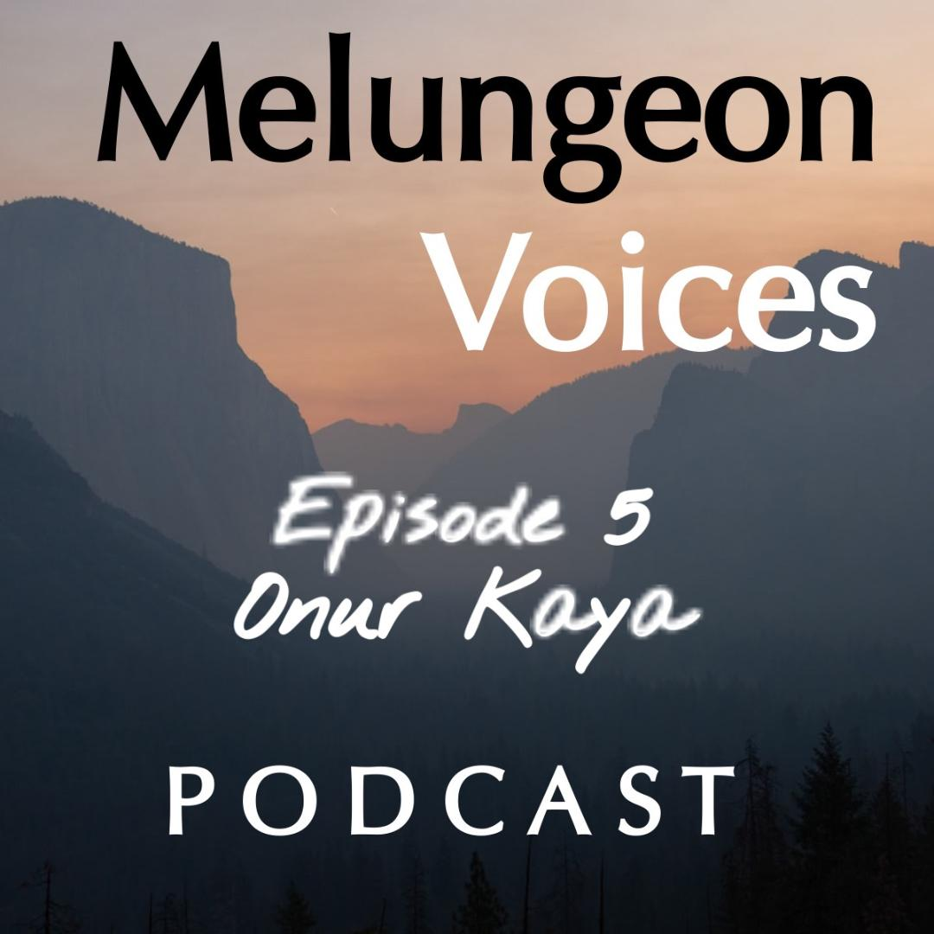

**Season Two Episode Five Transcript**

Lis Malone:

This is Melungeon Voices brought to you by the Melungeon Heritage Association. My name is Liz Malone. I'm the podcast producer and I am joined by Heather Andolina, who is your current sitting president at the Melungeon Heritage Association. How are you, Heather?

Heather Andolina:

I'm doing very well. How are you today, Liz?

Lis Malone:

I'm doing great. And you are smiling, as usual, always so upbeat. It's amazing. It's infectious

Heather Andolina:

Even in the morning.

Lis Malone:

In the morning. For today, Heather, we went international.

Heather Andolina:

Holy cow.

Lis Malone:

Yes. So, you had a very interesting conversation with Onur Kaya and aside from being a fascinating academic, what a nice person, just a warm, inviting human being.

Heather Andolina:

I know, he's so sweet.

Lis Malone:

So, if Onur is listening right now, which I'm sure he is, can't wait to use your spare bedroom when we come to Turkey.

Heather Andolina:

Yes, when we come to visit.

Lis Malone:

So, Heather let's fill everyone in so that they'll know a lot more about Onur and what you guys discussed.

Heather Andolina:

Sure, thing Liz. Onur Kaya is a professor at Budur Mehmet Akif Ersoy, located in Budur, Turkey. He has written several published articles and papers as well as presented at many academic conferences. The Bulungan people are one of his main research areas and the subject of his PhD thesis. And this episode Onur joins me from his home country of Turkey to share his extensive research on the surprising Turkish Melungeon connection.

Lis Malone:

Now, with this episode, because Onur, he does have an accent and he does speak very quickly. This would be a good time to alert listeners that the Melungeon Voices podcast is available in transcript form for not just for the disabled, but for anybody who would prefer to read the content. And where can we find copies of the transcripts?

Heather Andolina:

Yes. Anyone listening we will be putting the transcripts on our website at www.melungeon.org

Lis Malone:

Well, that's great. And I'm sure it'll be very helpful for listeners of all abilities. So way to be inclusive.

Thank you, Heather.

Heather Andolina:

You're very welcome, Liz.

Lis Malone:

And now let's take a listen to Onur Kaya.

Heather Andolina:

All right. I am pleased to have with us all the way from Budur Turkey, Onur Kaya. Hi, Onur.

Onur Kaya:

Hi, Heather it's nice to hear you.

Heather Andolina:

Yes. In which countries do you conduct your research?

Onur Kaya:

I have visited certain countries and I am planning to visit other different countries as well. First of all, I will talk about my own country, Turkey. In terms of research I conducted in Turkey, I focused on Ottoman archives. Ottoman archives are full of documents in our Ottoman languages. A Turkish person can't read or analyze them unless he or she learns the Ottoman language, thus is necessary to have an Ottoman language translator. I try to visit the archives, but the pandemic prevented me from doing that. However, things are getting better and for more detailed information on Turks and regions, other people who are taken to America and inter intermingled with Melungeon’s, a visit to Ottoman archives will be realized for the completion of the research. It has been necessary to carry on research in England due to England's connections with the new world and Ottoman's relations with England in the 16th century, when these Turks were taken by the Spanish to the new world.

Onur Kaya:

In terms of the research I conducted in England, I visited the British library, which keeps many old writings, however, these old writings are in the middle English, thus a translator of the middle English is needed or, was needed besides permission to look at archives were needed. The process for our planning board is continued. However, the visit to Turkey provides resources, which contribute to 16 century British Ottoman relations related to Turks in the new world, United States.

In terms of research, I conducted in America and I visited Illinois University. I would like to thank to Dr. Wood Pelton, who was Dean of Global Education at Illinois university in North Carolina and professor, doctor Catalina, who is a professor at English department, and one of the few academics in the world working on Melungeon’s they provided accommodation transportation and many more for my research.

Former chair of Melungeon unions, Scott Withrow also had significant contributions for my attendance to the 21st Melungeon union. He helped my transportation and accommodation, and I would like to help him.

Now the union chair, Andolina has so much contribution to my research by involving into such distinguished organizations. I like to thank her as well. So, these are the countries are conducted research, but also there is a Spanish and Portuguese part for Melungeon’s or Turks taken from Turkey or other ethnic groups such as Jews taken to the new world. So, if I had enough funding, I will try to visit to Spanish and Portuguese archives.

Heather Andolina:

Awesome. So, obviously your research is on the Melungeon people. How did you first learn about the Melungeon people?

Onur Kaya:

I want to state that absorbing and understanding people around you is very significant for successful results, which could touch millions. Melungeon’s are significant people to touch millions. In this perspective, I met such people who touched my life. I was taking PhD courses for my degree at the early 2010, and I was comfortable to stretch my legs on research subjects. At one of those courses, I attended the subject was American Indians and lecture mentioned that American Indian ethnicity extend to different groups, such as Melungeon’s, who have also connections with Turks and suddenly it turned to me in the classroom and thought that [inaudible 00:06:56] in such as subject for feature. You know, that there are theories of planting idea into the mind of people with different methods.

So, lecturer used one of the best methods and planted the idea in my mind, and I always kept that idea, which could touch millions for the right time. Thus, I wanted to reflect my interest and research on millennials at the highest level of my education. I will obtain and decide to reflect it for my PhD research. So that's how I, and when I learned about the Melungeon people,

Heather Andolina:

That's so cool.

Onur Kaya:

Thank you.

Heather Andolina:

Based upon your research, what connections did you discover between a Melungeon people in Turkey?

Onur Kaya:

I found out that for your question, I found that that Turks Spanish and Portuguese had many encounters on seas, the activities were common in the Mediterranean and even British courses was among these nations, which encountered others and to captives. In the perspective of Spanish at the battle of Atlanta in 1685, 11 times, which were sailors were captivated by Spanish sailors. Some of these captives were separated to row at Spanish ships. It could be said that in 1578 as in Spanish ships named Santiago passed the Atlantic Ocean and the ship they rode in for Armada de de Indias in America. In this perspective, as British was open of Spanish in Europe and America, as a result of the course activities in America, Europe, these Turkish captives could be captives in British ships as well.

These are defining with my limited opportunities as the Melungeon’s are multi ethnic and the origin aspects of different centuries and regions as from each of these countries need to search sources related to his own country because there are Spainish, there are Portuguese, there are Turkey, and there are other middle Eastern countries.

In this perspective, within my limits, I had the confirmation that Turks were taken to America and had been, then I had completed Turkish part of Melungeon coming here. There are so few academics and researchers researching on Melungeon’s however, I hope representatives’ academics of each ethnic group comes together, research at the country, he or she's related, and we put forth the complete picture of the Melungeon people in the near future.

I apply for different scholarships and I will try to detail and deep my research related to American part and Turkey, and try to reveal more information. And I would like to share it with such distinguished organizations as yours in the near future. Hopefully.

Heather Andolina:

Yes, definitely. Hopefully, maybe next year.

Onur Kaya:

Oh, hopefully. Yeah.

Heather Andolina:

Onur what conclusions, if any, were drawn from your research with regards to the Melungeon people

Onur Kaya:

About conclusions. I came across sources looking for American Indian and Turk connection, which I

thought the found of Turkish public also wondered. And I looked at the institutions he established on this subject. In this perspective, I came across resources such as, Turks and American News, are American Jews by the house Turkan, who was a professor at Columbia university in America. Therefore, I came across here claiming that people from Asia, where was the first hometown for most of Turks immigrated to America, by using the Bering Straits. In this was found books about people such as, local tab connection to Turks. In this perspective, I came across not Indian migrations, 1933 escape from genocide to America, similar to the, he claims, the passage of people from Asia to America after centuries of the previous immigration from Asia, he talks about the Turks who run away from genocide to Northern parts of America and blend to American Indians called Athabasca in that region, which compromises Alaskan Northern Canada.

In the current chronological order, I also found that Turks and Muslims contacts with the world in the 16th century, before the Columbus, a Turkish sailor called, called Peter a visited the Northern America shores and draw map of the shores. By obtaining information that America place C such as Indian’s ordination.

I searched books about Indians and came across books such as Florida Native Americans, finding peace in my heart, which tells his both American, Indian and Melungeon identity. Therefore, any window was opened as Melungeon in this perspective, I came across sources such as he was not from mountains, Melungeon settlement, which tells about origins ranging from European to Indian.

With this aim I looked at battles with among Turks, Ottoman Spanish and I focused on Ottoman taken to America by Spanish and Portuguese sailors at battle of the 16th century. And I found that they mixed into these multi ethnic people, forming Melungeon communities in the United. I need to say that as Melungeon’s are a multi ethnic community, at least one deserves needs to focus at least for his or her country.

In this perspective, I found out that Spanish, these Turks and who were captives for Spanish or Portuguese sailors was also issue of England because England had access to new world. And in this perspective Ottoman and British empire had a connection. In this perspective, I searched the books about two countries connections, which could look at those captive Turks. In this perspective, I found out someone was from England during the Renaissance.

The second book has been important because it talks about the letters between Salton and the queen.

And the letters revealed that the Turks were captivated by Spanish or Portuguese sailors and taken to America. And the Salton was requesting from Queen to help him to get back those Turks to Ottomans, unfortunately this didn't happen.

The Turks remained there, as many people know, and they intermingled with Melungeon’s there. I also look at other sources and I looked at Spanish and Portuguese archives in this perspective, academics, such as Spanish archives and wrote books such as, War in the Mediterranean Ottomans Spanish struggle, which tells about Spanish, Captive Martyrs has been, have been important books, which tell about the captives Ottoman and taken to the America.

Onur Kaya:

Some of them contained even names. I also learned that RQ in Spain is a significant place to search about these issues. So, I can conclude that Turks were captive and they were taken by ships, but for more detailed conclusions, for more detailed information, we need to look at the Spanish and Portuguese archives, which contain more names and more people history.

Heather Andolina:

That is so fascinating about the Spanish Portuguese and Turkish connection. I didn't know a whole lot about that.

Onur Kaya:

Oh, thank you. Yes.

Heather Andolina:

Yes. How does your research differ from other researchers on the Melungeon’s?

Onur Kaya:

Okay. There are very few dissertations on Melungeon’s, they are very precious for feature researches. These dissertations on Melungeon’s mostly focus on Melungeon features related to America. They're also significant critic books about Melungeon's past today, day life, and many information related to America. However, my research fell focus on connection of Melungeon to Turks, and other nations from the middle east, because Melungeon’s intermingled with nations, such as Turks and Jews, who were part of the Ottomans and immigrated to America from middle east other area.

Thus, I will shed light to the middle east on side of the ethnic background in Melungeon society. Besides that, things about Melungeon’s are very important to give information about the Melungeon’s many qualities ranging from their past to daily life. However, these significant works have not been analyzed yet. My research will put light into such works to reveal military analysis of done Besides a book about life writings, literary analysis, which will provide a literary approach to Melungeon writings. The way their identities are represented, the facts and myths about the representations of them will be provided. Thus, a book collecting information about all the life writings, books for Melungeon’s will be put forth. In addition to that, by the support of my wife and colleague, who is an academic at health sector, genetic findings about Melungeon’s will be put forth in my dissertation, which differs from other dissertations, which does not include such genetic findings about Melungeon’s.

Heather Andolina:

So, you mentioned the genetics, we're going to pose this next question to your wife, Betul Kaya, who is a fellow researcher with a specialty in genetics who assisted you with your genetic findings pertaining to the Melungeon.

Heather Andolina:

So, Betul, did you uncover any interesting genetic findings about Melungeon’s?

Betul Kaya:

I reserved scientific studies on the origin of the race of the Melungeon’s scientifically. I would like to share you the information I have obtained from articles and books about this subject in this perspective, one of the earliest resurgent Melungeon, origins could be named as anthropologist, William Hal Gilbert, and his article, Memorandum consigning the characteristic of larger, mixed, polite racial islands of the Eastern United States, which is from 1946, and includes Melungeon’s by his details list of mixed blood racial islands. From this point, if we need to talk about genetic information about Melungeon’s, it is necessary to emphasize that genetic research for any group of people in the world have been available many years later. It has been available to obtain scientific evidence about a group of people whose genetic qualities are researched.

By ability of obtaining genetic data for diverse populations, anthropologists, William Pollitzer and William Brown have published an article titled: Survey of Demography, Anthropometry, and Genetics in the Melungeon’s of Tennessee, an isolate of hybrid origins in the process of dissolution. Which puts the fourth measurement of seeking color hair from index, and genetic obtains from Melungeon’s in 1969. Their findings were in line with the Caucasoid populations which African and Indian influence.

They retained the traditional description of the Melungeon’s as a three racial hybrid. In 1990 anthropologists analyzed blood samples collected from Appalachian

Melungeon’s and compared the results. According to the analyzed result, he created a table in which he listed six of the closes’ populations matching to Melungeon’s. Less we forget the Melungeon colony of the last tribe in America. This table was their article titled: Toward a genetic profile of Melungeon’s in Southern Appalachia. They state that leading match found by Gutary were Libia in North Africa, the islands which were settled by Spanish and Portuguese Malta, which host a Mediterranean population, having Spanish, Italian Portuguese and Arab ancestry. Malta in Italian, Ireland, which is an island of the cost of Lebanon in Spain.

From this point as being in meeting point of these emphasize African, European, Mediterranean regions and in the table of the population of Turkey have similarities to Melungeon’s as well, but in terms of the population of Turks in the table, as in her work, Melungeon is the last lost tribe Hirschman claims, Turks were represented by a small sample. Therefore, it could be said that it may not be possible to obtain the precise similarity to level of Turks to Melungeon’s. In their article. Diego and Hirschman suggest that Melungeon’s were the answer is in Northwestern Europe, but represent an amalgam of Mediterranean, Middle Eastern, North African, in African, and native American ethnic group. In their study, which look at similarities of 40 years of Melungeon’s to diverse populations in the world. The genetic similarity results were shared. Many participants in the study, some similarities were found, especially with Morocco Tunisia, Algeria, Libia, Egypt, Syria and Turkey.

Betul Kaya:

This independent, studies support that the Melungeon population has many ethnic groups and racial origins. In the origins of the Melungeon’s the similarity with the Turks and other populations has been proven by scientific studies. However, to find more accurate and precise similarity level of Melungeon’s to any diverse populations in the work, these studies should be done with more samples populations. Thank you.

Heather Andolina:

Thank you so much, Betul.

Betul Kaya:

Thank you.

Heather Andolina:

Okay. So back to you Onur. My next question for you, are Turkish people familiar or even aware of the Melungeon’s?

Onur Kaya:

Actually, it's an interesting situation. In academic field, many colleagues hear that I research about Melungeon’s, and they ask who they are, besides they ask the connection of them with Turks and the people in the region. When they have their answers, they find it very interesting. My colleagues and supervisor find the Melungeon’s very original and supports me for my research. However, I can say that most of the people I talk here in Turkey are not aware of the Melungeon’s. Still, there are interesting examples and people who are aware of Melungeon’s. But I don't come across many people who are aware of Melungeon’s.

I came across a guy who works at a copy center. I was copying some of my research to present it in a speech. And the guy looked at the copies and told me that whether I'm researching about Melungeon’s. I was surprised and asked how he had information about Melungeon’s. He was so keen in his manner, and claim that they are Turks immigrated to America. So probably he was a Patriotic man. He was focused on that part, so he kept in mind probably. So, a person at copy center was already aware of the subject. Turks care about their ancestors and journeys to America, so I noticed that if it's their interest, common people could be more aware of a subject than the researchers have about it here in Turkey.

Heather Andolina:

I love that. Like how random is that? That's so cool.

Onur Kaya:

Thank you.

Heather Andolina:

So going back on your research, what's been the most fascinating information you've obtained.

Onur Kaya:

There are really fascinating points, issues about Melungeon’s, but about my research, I noticed that

Turks internally with Melungeon’s has been the subject of even the Queens and Sultans, as far as I search.

It is known that many of these Spanish ships went to America. So, Turks could have fled from the Spanish ships, which were wrecked or arrived in America. As prisoners of war has always been issue of countries. For Ottoman Sultan it was an important issue. So, he wanted to save his men from Spanish people from the neighborhood. It is known that British empire has also interest on America in the 16th century. At these times British and Ottoman empires had good relations and magnificent. The Ottoman Sultan contacted British Queen Elizabeth to contact Spanish forces for the release of Turkish prisoners of war. This also included the Turks in the new world, so interestingly Ottoman and British Queen had letters on this subject.

It is possible to these data's, which are at Ottoman archive in Istanbul, Turkey, and furthermore only just one English academic person this. It is still there to be revealed, to put into the daylight of our lives. So that is interesting for me about Melungeon’s.

Heather Andolina:

That is very interesting. What will be your next move related to Melungeon’s? Do you have any future plans in Turkey relating to the Melungeon’s?

Onur Kaya:

Melungeon’s is an important gate opening the research areas for the Turks in the United States. In this perspective, I would like to extend my research to Turk groups, which could have connections with other groups, such as more local type connections with Turks, Melungeon’s, and Indians who are believed to be connections with Turks. There are previous researches that focuses on the relations between American Jews and Turks. In this perspective the founder of Turkish played important roles to lead the way to the researchers. I would like to continue and contribute to these researches. I have findings that Turks had extended their ray to Alaska. I will reserve their connections with Melungeon’s who are known to be spread all over America. In this perspective, my future plans are to be in Turkey about Melungeon’s. I want to make people more available of the connection of Turks and people from this region to the Melungeon’s and America.

Thus, I am visualizing all the researchers I do. I take videos, record, record voices, make interviews, write papers. I would like to transform all these to a Turkish documentary besides, I would like to hold a conference focusing on Melungeon’s and other ethnic groups from America who has connection with Turks. I am planning to make all this spread on the social media, and to be heard by more people who may contribute to Melungeon research as it can't be done by one single person from Turkey.

In this perspective, Melungeon union, and Heather play significant rolls because the union and Heather realized such things as documentaries, conferences. Corporation with the union, Heather and the Illinois University which also supported me will be great for my future plans to be in Turkey. [inaudible 00:28:11] Melungeon unions to be realized in Turkey. Maybe hopefully could be good future plans.

Heather Andolina:

Yes. I 100 percent agree with you on all of that, Onur.

Onur Kaya:

Thank you. You're always there for me.

Heather Andolina:

Yes, I am. I love this. So, what would you suggest other researchers look for in the future when studying Melungeon’s?

Onur Kaya:

Yeah, this is a very important, because Melungeon’s has a lot to research. For Turkey part there must be more research at the Ottoman archives in Istanbul, and at the same time the required financial support is needed to realize in Spain, Portugal, and England. Such a process is needed for America to know how these people want to interior parts of America and mixed to other countries, thus, in order to have a detailed and completely verified research and results about Melungeon’s and international and wealth finance project needs to be carried. When I was in America for my research, I requested many sources from different libraries, universities, and archives to library of Illinois University. Among them there were many microfilms inbox and there was microfilm reader at the university. Each of these are full of thousands of film squares, which lead to the thousands of letters, hand writings, media prints, and many more.

And they were from different decades. I had just more than two months, and it was not possible to look at all this, but if there could be more time, I mean, lots of years of study or study of many people, there could be many other outcomes for Melungeon research. There could be more genealogical information because they are there, there could be more historical information related to, past Melungeon’s and their culture and their day life. There could be more literary information related to them. We know that it's possible to write a book on Melungeon poetry. There are enough sources at reach, but it was not written yet.

We know that it is possible to write a book on Melungeon drama, because there are drama types of Melungeon, and it is in reach, but this book was not written yet. We know that it's possible to write a book about Melungeon fictions. There are enough sources, but it was not written yet. We know that it's possible to write book and Melungeon non-fiction there are enough sources at reach, but it was not recent at month by, but my sortition will be that book. It will look at Melungeon non-fiction. So, these are my suggestion for feature research researchers.

Heather Andolina:

That is awesome Onur, and I can't wait your future book on the Melungeon people.

Onur Kaya:

Thank you. You're the first person that I will share it.

Heather Andolina:

I'm looking forward to it.

Onur Kaya:

Thank you.

Heather Andolina:

Thank you so much for taking the time to talk with us today. It's been an absolute pleasure.

Onur Kaya:

It's been an absolute pleasure for us as well. It was really nice to hear your voice. We, we missed to talk to you.

Heather Andolina:

But you know, hopefully we'll get to see you next year at the 26th Melungeon Heritage Association Union.

Onur Kaya:

I am going to apply two different Fulbright scholarships. Hoping to get at least one at the same time, my wife is also applying a Turkish type of scholarship. We will be applying three scholarship types. Hopefully one of them will be acquired by one of us, and we'll be visiting the Melungeon Union next year.

Heather Andolina:

Yes, I can't wait.

Lis Malone:

You've been listening to the Melungeon voices podcast on behalf of myself, Heather and Alina, and the entire MHA executive committee. We'd like to thank all of those who participated in making this episode possible. For more information, you can visit them on the web at melungeon.org. That's M E L U N G E O N. ORG. The information views and opinions expressed in this podcast episode do not necessarily represent those of the MHA. Melungeon voices is presented by the Melungeon Heritage Association. All rights are reserved.