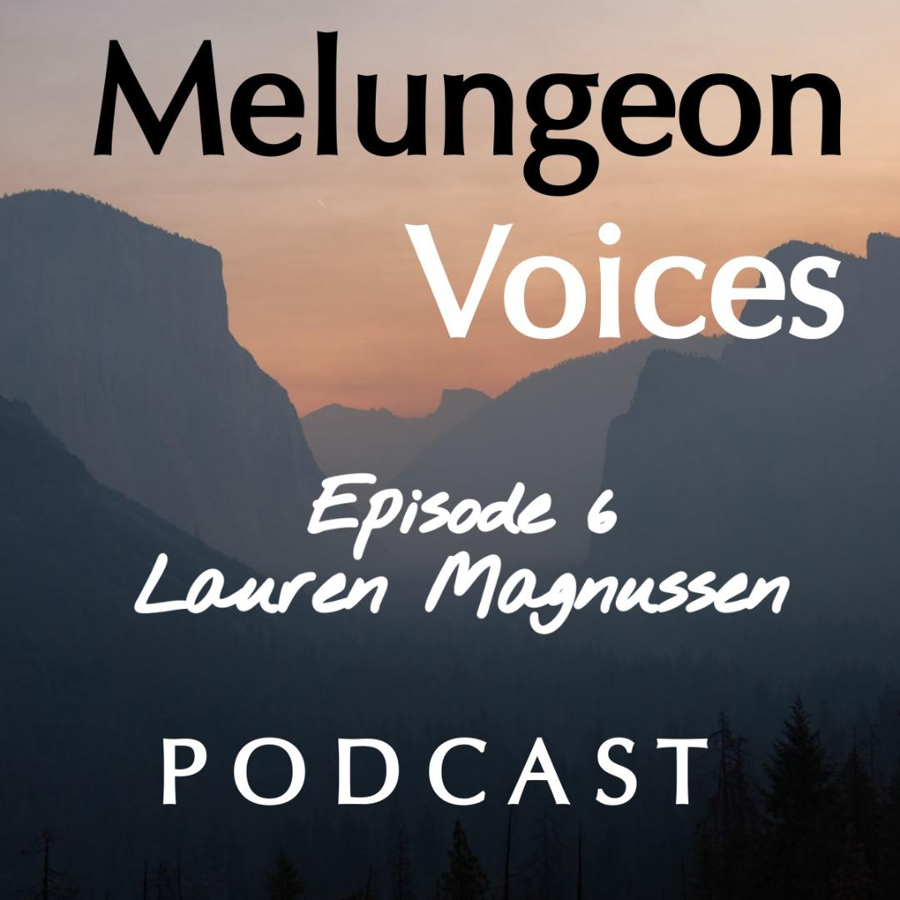

**Season Two Episode Six Transcripts**

Lis Malone:

Hello, and welcome to the Melungeon Voices podcast, presented by the Melungeon Heritage Association. My name is Lis Malone, and I'm with Heather Andolina, the presidents of the Melungeon Heritage Association. Good Friday to you, Heather.

Heather Andolina:

Yes, it is. Thank goodness it's Friday. TGIF. Yeah.

Lis Malone:

TGIF. Friday is not only a good start to the weekend, but it is podcast day for us.

Heather Andolina:

Yes.

Lis Malone:

So, if you've been following along with this podcast series, which we hope you have, we are currently at episode six of the second season of the Melungeon Voices podcast. And oh my gosh, Heather, this season is flying by.

Heather Andolina:

I know. I can't believe it.

Lis Malone:

We're not ready for the season to wrap up. We're just not ready.

Heather Andolina:

No. If it was my decision, we'd have so much more, but we can look forward to maybe a season three.

Lis Malone:

Well, if you guys are enjoying this content and enjoying all of these great interviews that Heather and I have been cultivating for you, then please support the MHA. Because the MHA, their donations, their membership dues, that is directly funding this type of programming. So Heather, tell people how they can become a member if they're not already.

Heather Andolina:

Yes. So, of course, visit us at our website, melungeon.org, to become a member or to even just donate. You can do both.

Lis Malone:

We're crossing fingers for a season three.

Heather Andolina:

Yes.

Lis Malone:

But we're still in season two, and we're still enjoying this ride, and we're having a great time bringing all these wonderful dialogues to you. So, in addition to taking donations, the MHA has a very informative newsletter as well. So Heather, give us a little information about the newsletter, the frequency, and who's eligible to receive it.

Heather Andolina:

Yes. Becoming a member of MHA, you will receive our quarterly newsletters. We have one in the winter, the spring, summer, and fall. And in our newsletter, we really love for our members, especially, to share their family stories with us. So we always have family stories, as well as history about the Melungeon people. And then just updates. We put in updates about what's going on at the Melungeon Heritage Association, what's going on with other genealogical societies, things like that. So, it's a really... It's very informative. It's great. It comes with your membership. People love it. Oh, I also want to give a shoutout to Danielle Caudell.

Lis Malone:

Danielle. Danielle Caudell Stamper, who is the wonderful wizard of oz behind the curtain who makes the newsletter possible for the MHA. So, bravo to Danielle. Hi there. We're thinking about you. We miss you.

Heather Andolina:

Yeah.

Lis Malone:

So, the newsletter is a wonderful segue into this week's guest, Lauren Magnussen, who has been featured in the newsletter as well, correct?

Heather Andolina:

Yes.

Lis Malone:

So, let's talk about Lauren and hear about what you guys talked about this week.

Heather Andolina:

Okay. Lauren Magnussen is a production editor at Mascot Books with a bachelor's in English from the College of William and Mary, and is currently pursuing her master's degree in English literature. She worked in academia and professional theater prior to transitioning to her dream job in book publishing. In today's podcast, Lauren and I discuss how she first became interested in learning about the Melungeon people and how it influenced her subsequent research and writings.

Lis Malone:

Fantastic. Let's listen in.

Heather Andolina:

I am pleased to introduce today's guest, Lauren Magnussen. It's fantastic to have you with us on the Melungeon Voices podcast.

Lauren Magnussen:

Well, thank you so much. I really appreciate it.

Heather Andolina:

Of course. All right. Well, let's get into it.

Lauren Magnussen:

Yes. Absolutely.

Heather Andolina:

How and when did you first learn about the Melungeon people?

Lauren Magnussen:

That is great question to start off with. And the nice thing here is that I get to shout-out to my mom.

Heather Andolina:

Aw.

Lauren Magnussen:

So, she actually introduced the Melungeon community to me out of a complete mere coincidence. So when I was a child, she was diagnosed with sarcoidosis. And that was, at the time, it was a genetic, I think, disease that at one point was claimed to be prevalent in Melungeon DNA. I think there's a book on it from Brent Kennedy, who we all know very well in the community.

Heather Andolina:

Yes.

Lauren Magnussen:

And so, I'm not... I don't want to make any claims about the science of it because I think some of it is... A lot has come from between the time that book was written and now, but that was a hypothesis at one point. So my mom didn't really know much about it. There was no Google. So, she was just looking around, and so she stumbled upon Brent's book. And so she was reading about it and learning about these people in this community. And so, she just gave me the book one day as she was researching, and I read about it, and then shelved the book just along with all my other books.

And then fast forward, about, gosh, I guess 20 years later maybe, I'm working on African-American history for graduate school. And I'm trying to think about what I want to research and what I want to focus on, and I was spitballing with my mom a little bit and she reminded me of this book. So I pulled it out and I just started rereading Brent's book and just absorbing everything. And I just thought... I just had this instant connection to this community that is underserved and not always spoken about. And that's I think what Heather's work is kind of about, what my work is about, what everyone is trying to do, which is to give these voices a voice or to give these people a voice and to really bring these stories to the front.

And so, I just saw this need in academia, this vacuum where this community wasn't really being represented. And I found it so intriguing that the Melungeon community is made up of multiple races, and blends of races, and just very influx, and there's just a lot of nuances to it. And I just felt like that would be a great avenue to go down and explore, research, and try to bring those voices to the forefront. And so, it was... It's crazy. It was just really a fluke. So, my mom just got a book for me 20 years ago, and it's incredible that now, I'm here talking to both of you about this history. So, kind of started with the family connection and just kind of very organic.

Heather Andolina:

That is so cool.

Lauren Magnussen:

Yeah.

Heather Andolina:

Let's get into your writing and research on the Melungeon people. You discuss in both your graduate paper and published articles, how the Melungeon people are missing from the history books. How did you come to that conclusion?

Lauren Magnussen:

Yeah. I came to that conclusion when I was reading up on all of the scholarship from the reconstruction era during the civil war as well. And just doing a deep dive into that period of our history and really looking for representation of people who are either in-between races or who are referred to, in different ways, outside of just black or white, which is this common binary that we see in history where we're always having these... Instead of looking at race and society on the spectrum, our history books often try to really make binaries and talk about black versus white, or just really stick to these firm categories of race. And so, I just kept running into that, both generally in scholarship. And then when I decided to start focusing more on Melungeon heritage, that's when I started realizing how I just couldn't really find much about them at all.

So, it's kind of once you really start to get into it, that's when you find the absence. You tend to notice absences only once you're kind of getting into the scholarship. I planned to research the Melungeon community for graduate school. And as I started that research, I just wasn't really finding anything outside of members of the community. So, a lot of my sources were coming from people who identify as Melungeon, people who are in the community. So, a lot of my source work really came from people, like the two of you and everyone who participates in the MHA. And so that's how I started noticing, is that I went searching in some of these traditional source materials, like well-regarded history books, respected journals, and scholarly sources. I just wasn't really finding much. And I had to keep resorting to folklore or oral tradition, which is fine, I think. But the point is that it just shows how there was that absence. So that's how I first found it. And I was finding so much online, but so little in physical books.

So that's also a distinction that I noticed.

I came to the conclusion about that absence mostly because I wasn't finding anything, but also in terms of what those sources were, which I just touched on in terms of internet sources versus print sources. And that's how you tend to know something is a little hard to find, if a lot of what you're finding is blog posts, or the oral tradition, or stories told over time, or fiction. And that's when you tend to notice, if there's a lot of that versus, you're not finding a whole lot in non-fiction sources, and that's how you can also tell. So that's the conclusion that I came to initially when I was just thinking about reconstruction era scholarship. But then over time, as I looked into Will Allen Dromgoole and some of the folklore, that's when I just kept noticing it over and over again. So that's the conclusion I came from. And what I'm so hopeful for is to see that change.

Heather Andolina:

Yes. Great. Going on what you just mentioned about racial ambiguity of the Melungeon people, there's a quote about the Melungeon people. "They were either too white to be black or too black to be white." From your research, what are your opinions of this quote?

Lauren Magnussen:

Yeah. I think that is such an illuminating quote because it reminds us that... That quote, I think implies, I should say, that the Melungeon people can't fit into certain categories. And so, I would argue, that means we need different categories. I think that quote is so interesting because it does speak to that black-white binary. And I also think there's an interesting sense of what it means to be black or white because I think that quote implies as well that there are true white aspects or true black aspects. And if you can't fit into either one of those, then your identity is just ambiguous. And so, while there's a part of me that kind of agrees with that quote, because in a sense, that is how people, I think over time have viewed Melungeon’s, it's just, they never quite fit in. And that's why it's so hard to categorize them or maybe find them in the books.

And I think what is so powerful about that quote is that it really speaks to how much people want to define Melungeon’s through black and white. And so, I think I would argue for definitions of race or identity that go beyond just black and just white. Because especially having heard from people who identify as Melungeon and reading books about Melungeon communities and their culture and customs, it's so fascinating how practices are pulled from all of these different places. You have indigenous sources, Native Americans, and then African, and then Anglo-Saxon. You just have all of these different influences. And so, I think people so badly want to think of them in terms of that racial binary. And I think we need a new kind of vocabulary or way of thinking them that isn't that literally black and white, that black and white system, I guess.

So yeah, so that ambiguity, I think, is what makes the Melungeon community so... It makes it hard to categorize them and it makes them harder to write about in history, given I think the language that the United States has used about race over the last few centuries. I think we're getting better about it here, and I'm hopeful moving forward that we'll be able to come up with a vocabulary and ideas that can express Melungeon heritage in a way that's not oversimplified, in a way that embraces all of the differences, and the ambiguities, and all the different customs that are associated with the community.

Heather Andolina:

I completely agree with you, Lauren.

Lauren Magnussen:

Mm-hmm (affirmative).

Heather Andolina:

Were the Melungeon’s ostracized because of their lack of "race"?

Lauren Magnussen:

Yes. That is definitely what I have found in my own research, and that is definitely what I would argue. I've written a couple papers about this and I'm just really excited to be given the chance to talk about this. So, thank you, again.

Heather Andolina:

Oh yes, definitely.

Lauren Magnussen:

Yeah. And so that is absolutely the conclusion I have come to. And while I hate to make definite assertions about history, I think those can be a little tricky. I would say that that feels very factual in terms of what I've encountered. And also, from research that I've learned from people, like Wayne Winkler and other people in the Melungeon community who have done such an incredible job of tracing the history of the Melungeon community and the people. So, I definitely learned a lot from people who came before me for sure.

But then when I've done my own research, I was just finding source after source, where Melungeon’s were just... People would go out of their way... In the sources from the 1800s and 1900s, they would describe the Melungeon’s in these strange terms. They would talk about how they're literally unclassifiable, how they don't fit in, how they can't be categorized, and therefore they're strange. And just all of these terms are used for the, and there's this constant confusion about how they fit in, and they're never associated with good traits, is also something I've run into. It's hard to find any sources that say positive things about the Melungeon people, and I think Will Allen Dromgoole had a lot to do with that, certainly.

But even putting Dromgoole aside, source after source that I found were just always talking about how we don't know how to classify them, therefore we don't understand them, and therefore we don't like them. And it was very clear. And that was something that I don't think I was expecting to see when I started my research. I thought it was going to be harder to find really equivocal, obvious thoughts about Melungeon’s. And then to find these sources where people are just literally saying, "We can't define them. We don't get it. We don't like them," how that affected laws, and how hard it was for people to classify Melungeon’s in the legal system. And so, they were often shunted, I guess, to decide, and were never really integrated into society though. Integration might not be the right word, but never accepted, I guess, into society, or even people don't even really maybe even know who they are or that they exist.

It's a shame. But I guess I've seen just over time in these sources that if people aren't checking very specific boxes of black or white or indigenous or anything like that, it was so hard for them to be accepted into society or even to prove that they exist. Just our legal systems, our cultural systems aren't really set up to have these multiple kinds of heritages. And so, I think that is something that we have to get past. And again, that's also about finding the right vocabulary and understanding that 100, 200 years ago, there just wasn't this vocabulary of inter-racialness. And so, I think that realizing that when we look back at these sources, that they didn't have that vocabulary and trying to resurrect Melungeon’s from the historical record, I think will always be tricky because of that.

Heather Andolina:

Lauren, that's exactly true. I didn't know about the Melungeon people till a few years ago. And they're my ancestors. What intrigued you most during your research on the Melungeon people?

Lauren Magnussen:

Yeah. I was so intrigued by how strong the on-the-ground support is for real Melungeon communities. I think I was just so impressed by the people today who are taking that torch, and doing the research, and doing the legwork. And I think the Melungeon community has been overlooked and just not seen by the historical record for so long, that I was expecting it to still feel that way when I did my scholarship, but I actually felt the opposite. I remember when I wrote one of my papers on Will Allen Dromgoole, I kind of ended the paper talking about my hope for the future. I think I even talked about podcasts, I think, about how the future is with web forums, and podcasts, and documentaries, like Heather's, and just all of these different multimedia experiences. That was not what I was expecting. And so to see that happening has been absolutely thrilling because I really think that's where the future is.

And I think it's stunning to see how little representation there is in the past, yet how much progress I think we're making going forward into the future. There's a lot going on in the present in a way to make up for what we're not seeing in the past, and that was something that really surprised me to see. I think it's so easy for communities to get overlooked. And to see people within the Melungeon community, bring voices, and bring that power, and not be forgotten, to make their own history and remind people of the history, I think that is just so empowering, and I think that is definitely the direction that a lot of "forgotten histories" or forgotten people should be going in.

And so, I think that the very presentness, the futurism of Melungeon identity, I think, was the biggest welcome surprise because I was frankly a little nervous when I started the scholarship. I was worried I was going to find a lot of dead ends, but the opposite happened. I found a lot of open doors. And that's how I found Scott Withrow, and then Wayne Winkler, and then that led me to Heather, and then here I am. So, I just, I found so many open doors when I thought I was going to find closed doors. And if anything, I think my research has actually broadened in a way that I didn't expect also. I thought it was going to be one paper, and I would just leave it there because there wouldn't a way for me to really pick up and keep going. But because of the MHA and all the people that I've met, I've been able to keep going with my scholarship because there are more ends to follow or more leads to follow. So, I think that was not at all what I was expecting, and I think that has been an absolute joy.

Heather Andolina:

Aw. That is awesome, Lauren.

Lauren Magnussen:

Yeah. Yeah.

Heather Andolina:

That is exactly what we do here at the Melungeon Heritage Association. Yeah. So no, I love that. Thank you so much. We would love for you to share information on how our listeners can follow your work.

Can we find you on the web and social media?

Lauren Magnussen:

Yes. Absolutely. So, I have a website. It's just my first and last name dot com. And I do some articles for the MHA newsletter, which Heather has been so great about letting me contribute a voice or at least extend the scholarship. Because even though my family doesn't have a background of the Melungeon heritage, I'm always constantly aware of my perspective and not wanting to overstep. I hope that I'm more bringing a microphone for others and helping to expand research. So, I write articles occasionally for the MHA newsletter. And then I'm continuing to do scholarships at my college, which hopefully, I'll be able to publish. I have a website that's available. But otherwise, I can also be found just publishing in the newsletter. People can try to get in touch with me through Heather or through the newsletter. I'm always happy to hear what people have to say and always looking for new leads to chase, I guess.

Heather Andolina:

You do an excellent job, Lauren. I love reading your articles for our newsletter. They're fantastic. And I just want to thank you for being with us today on our podcast.

Lauren Magnussen:

Oh no, thank you. This was amazing.

Lis Malone:

You've been listening to the Melungeon Voices podcast. On behalf of myself, Heather Andolina, and the entire MHA executive committee, we'd like to thank all of those who participated in making this episode possible. For more information, you can visit them on the web at melungeon.org. That's M-E-L-U-N-G-EO-N.org. The information views and opinions expressed in this podcast episode do not necessarily represent those of the MHA. Melungeon Voices is presented by the Melungeon Heritage Association. All rights are reserved.