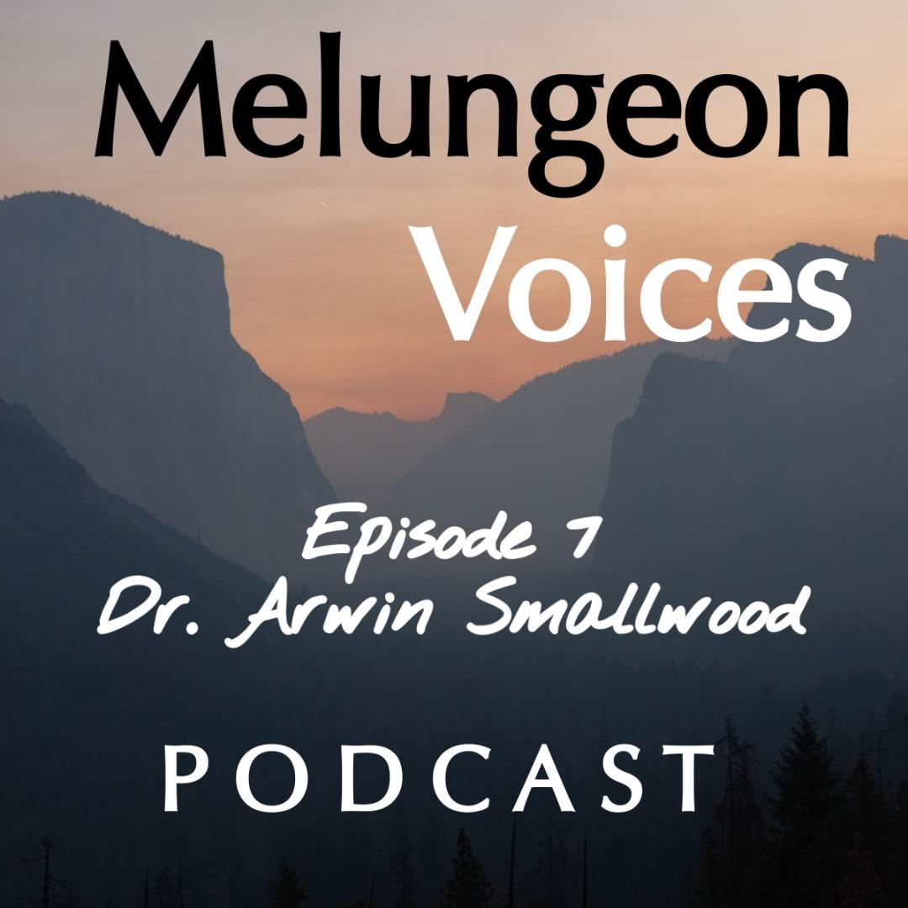

**Season Two Episode Seven Transcripts**

Lis Malone:

Welcome to the Melungeon Voices Podcast presented by the Melungeon Heritage Association. My name is Lis Malone and I'm here with Heather Andolina, who is the president of the Melungeon Heritage Association. So, Heather, here we are again, the final episode of the season, wrapping up season two. Mixed emotions, right?

Heather A.:

Yes. It's always so sad.

Lis Malone:

Heather and I will never see each other ever again. No, but in all-

Heather A.:

We have too much fun.

Lis Malone:

We do, we do. We definitely do. But in all seriousness, this has been an amazing season of conversations. So, congratulations to you and the MHA for really cultivating such a wonderful and informative group of people this year.

Heather A.:

Well, thank you, Lis. And of course, thank you for all your help. This could not be possible without Lis's help on this. Her co-hosting and her producing, and editing this. She's amazing. So, we really thank you from the bottom of our hearts.

Lis Malone:

So, Heather, I'm actually going to crown myself as an honorary Melungeon, if that's okay. Can I do that? Can I-

Heather A.:

You can totally do that. I'm perfectly fine with that.

Lis Malone:

I feel like I've learned so much about The Melungeon people, and I feel like I'm practically a Melungeon, so I have to at least be an honorary Melungeon. I can totally live with that.

Heather A.:

Yes. You have my permission. You have my blessing.

Lis Malone:

The president has said I can be an honorary Melungeon, so it's there.

Heather A.:

Yes, Lis Malone, you are.

Lis Malone:

It's been recorded.

Heather A.:

Yes. It's been recorded, but no, definitely. Thank you so much.

Lis Malone:

Well, it's been my pleasure and it's been a wonderful adventure for me in learning so much. So for this week, last but certainly not least, we have an amazing guest, Dr. Arwin Smallwood, who was also a wonderful speaker during this year's annual conference for the MHA.

Heather A.:

Yes.

Lis Malone:

So, anyone who attended that conference, this is certainly not a repeat. This is a whole new conversation and he just really brings so much to the discussion about The Melungeon’s.

Heather A.:

Yes. He's so wonderful. And, he's a great wrap-up to our season.

Lis Malone:

So, why don't you give everyone a little bit of an overview about Dr. Smallwood who may not be familiar, which, oh my gosh. If you're not, you need to get his name in your brain and what you guys talked about.

Heather A.:

All right. Thank you. Lis. Dr. Arwin Smallwood is Professor and Chair of the Department of History and Political Science at North Carolina, Agricultural and Technical State University in Greensboro. His research primarily focuses on the relationships between African American, Native American and Europeans, and Eastern North Carolina during the colonial and early antebellum periods.

Heather A.:

Wrapping up our podcast season two series in this final episode, Dr. Smallwood and I examined the intersection between European, African, and indigenous peoples or to those who attended the MHA's virtual conference this year, the interrelationship between the lost colony of Roanoke, the Tuscarora people and the Melungeon people.

Lis Malone:

Now, that's saying a lot, Heather. Let's listen in and hear your discussion.

Heather A.:

Dr. Arwin Smallwood, welcome to the podcast. It's so wonderful to speak with you today, and I can't wait to get into a discussion today.

Dr. Arwin S.:

Well, thank you. I appreciate it, Heather. Thank you for the opportunity to be here.

Heather A.:

Of course. So, we're going to start off with... Would you please share your story of how you learned about your own unique ancestry?

Dr. Arwin S.:

I'll try to make it brief, but in the little community I grew up in called Indian Woods, we all kind of took our heritage for granted because the families had been there for hundreds of years. If you would look at the different families, there were all different colors and had different colors of eyes, but we considered ourselves African American because we were obviously more African American than anything else.

But clearly, there were members of the community who were fairer and they appeared to be Indian, they appeared to be obviously a mix of light, they had green eyes, blue eyes, we call them hazel or gray eyes. So, we took those things for granted. It was just family. It was a community. Everybody was related by blood. And, if they weren't directly related by blood, they were seen as an aunt or an uncle and they were kin.

And it wasn't until I went to college that I really understood the unique nature of my community. And then, that was when I took a North Carolina History course. And in the North Carolina texts, it referred to my community, which was called Indian Woods by name in the second chapter of the book. And, they talked about it being a reservation given to the Tuscarora Indians after the Tuscarora World War.

And at that point, I really became even more interested in understanding that we had this Indian ancestry and we've been living in this area for such a long time. Who were we? And, that would help me understand why we were so diverse and why we looked the way we looked.

Heather A.:

So, would it be safe to say that your ancestry influenced your path to becoming a historian?

Dr. Arwin S.:

Without question. When you're living in history, and when I say hundreds of years of history, I literally mean hundreds of years of history. On both sides of my family, my father and my mother's family have both been from the community. Which is not a very large community, by going back before slavery, during slavery for hundreds of years. And we know where everyone's buried, at the church since the civil war, everyone's buried at the church.

But prior to that, there were a number of unmarked slave cemeteries that are scattered all over the community that locals of course would know. And then, Indian burial Browns that were very well known to my grandfather and my ancestors. So, without question, when you're growing up in a community and you're being supported by and loved by people around you, your family, you go to church together, you go to school together like this.

You don't think about your history, but when you get outside of that community and realize that you're different than other people, because you just assume that's how everybody is. That's when you start to appreciate it. So, taking that North Carolina History class and realizing that Indian Woods was a unique place. That it was so unique that this Leffler and Newsom wrote the history of North Carolina. They were well-known professors at the University of North Carolina Chapel Hill and their book on North Carolina history was the book, the Bible of North Carolina history.

And you're mentioned, your community is mentioned. But that's it, the names mentioned and no one knew anything else about the... at least there wasn't anything else in the book about the community, nor could you find any books about the community. So, that inspired me to write it. And one of my professors, when I went into graduate school to work on my master's in history, I had to do a master's thesis, which would be whatever history I wanted. And I asked, could I write a history of my community, Indian Woods? And my professor said, "If you don't write it, nobody else will." So yes, without question, that's what led me to become a historian.

Heather A.:

That is so cool. I love it. This past summer, you delivered a compelling and highly informative presentation during our recent 2021 Annual Union Conference, which was held virtually this year. And again, thank you for your participation. The connection between the Melungeon people, the Tuscarora and the lost colony of Roanoke, would you please provide a few key takeaways for those who were unable to attend?

Dr. Arwin S.:

The first really major takeaway is that... and I've had the honor of visiting with Melungeon’s in the mountains at places like the Home Place, Vardy Valley, but also in Wise Virginia, but throughout Appalachia and have found them to be very warm people and have a very rich history. And, they often talk about things like the evil eye. They talk about this mixed heritage of possibly Muslim and Jewish heritage, whatnot, but they're not sure exactly where it came from, right? It's kind of like they're in the mountains.

So, one of the takeaways is that you have to go back and understand, and it's been kind of left out even out of the North Carolina narrative, that prior to the whites being left at Roanoke, there were over 700 somewhere between five and 700 Maroons, which are runaway slaves who were in the Spanish Islands and the Caribbean, who were a mix of [Mos 00:09:13], Muslims, Jews, but a mix of different ethnic groups, including Caribbean Indians who were left at Roanoke island a year before the whites were left in 1586.

And, no one's ever cared about what happened to them, but these were individuals who were armed.

They were given English guns and led, and they also had survived in swamps in Jamaica and in Cuba. And Puerto Rico and they were picked up and brought and left in Eastern North Carolina. So, it's very clear when you look at it now that these people blended with the local Indian populations who were decimated by diseases that were brought by English when they first arrived in 1584, 85.

So, you see the Machapunga people. And then, even these stories that are amongst the Melungeon’s, it's amongst Machapunga's and the Melungeon’s, the Machapunga’s, they were known to have six fingers. And oftentimes, the Melungeon’s are said to have had six fingers. The evil eye, the Tuscarora eye, because so many of the Tuscarora Indians had blue eyes, green eyes, and gray eyes, which were unlike any of the native peoples that were there. And the Machapungas, the Mattamuskeet, the Bear River, and Tuscarora’s all were in Alliance and intermixed with each other.

So, it's just understanding history, right? Really understanding what took place. And this is happening in the 15, 1600s. And then, these mixed Indians the Tuscarora become very mixed and they're tri-racial. They get pushed if they're not enslaved during The Great Tuscarora War. They're pushed into the Piedmont and eventually into the mountains of North Carolina, Tennessee, and Virginia.

So, I think those are the key takeover ways, that most of the time, what I found in my research in starting in Indian Woods and with our mixed heritage in Indian woods is that every community thought it was unique. There are other communities in North Carolina that are similar and have the same kind of ancestry. There are other communities in Appalachia, in Tennessee, Kentucky, and Virginia, and West Virginia have the same kind of history.

But they think they're unique. They think, well, this is just our little community here in Vardi, and they don't understand the connection and how they got to be in Vardi, and basically, they were fleeing persecution because if you had any mixture, once Virginia and North Carolina established slavery, if you had any mix, you would be classified as black or as Negro. And then you could be enslaved.

So many people of color moved ahead of colonial settlement and found isolated places to settle where they would hopefully not be bothered. And the mountains were a very safe place until the flights started to penetrate the mountains and they wanted the fertile valleys. So, many of these people were run up into the hills. They had to go up into an isolated areas that were hard to get to, or up into the mountains, into the size of the mountains.

Heather A.:

Now, I remember you saying something about, that they followed the rivers, from North Carolina into Tennessee. Can you talk a little bit about that?

Dr. Arwin S.:

Well, that's a reverse pattern, right? If you go to the earliest history of native settlement in Virginia, North Carolina, the Tuscarora Indians who settled in North Carolina and pretty much were the major nation of Indians in North Carolina, from the Howard Banks of North Carolina to the mountains. Oftentimes, when people think of natives in North Carolina, they think of Cherokees, but the Cherokees were really in Tennessee and they were in the heart of Tennessee and they were in North Georgia and that extreme Southwestern part of North Carolina.

The dominant group in North Carolina, north of the Catawba and Catawba River and Cape Fear River were the Tuscarora’s. But they came into North Carolina, the history of the Iroquois and I touch on this in the presentation. They come into North Carolina out of the mountains and out of Ohio, there's a ancient city in Southern Illinois, where they come out of the Ohio River Valley.

But in Southern Illinois, there's an ancient city called Cahokia. It was an ancient city, a mountain city very much like the cities of the Aztecs. And that's where all of the Iroquois people originated as one people and they move east into New York and down into North Carolina and they break up into these different families, these different nation Mohawks, Oneida's, Onondaga's, Cayuga's, Seneca's, Tuscarora's, Meherrin's and Nottoway's.

And, the Tuscarora and the Meherrin, and the Nottoway come out of Virginia following the Roanoke River out of the valley. They were in Virginia and the Roanoke River, the source is in Roanoke, Virginia, but it goes all the way down through Virginia, North Carolina, and then it empties into the Albemarle Sound in Eastern North Carolina, near Bertie County, or Southern border of Bertie County.

So, the original migrations is the people are coming down. This is ancient migration, ancient Indian migrations, they're coming down that way. So, when whites begin to push west and push the Indians out of the east, into the west, many of the native people are following those rivers right back to where they came from. So, the sources of the other rivers because the Tuscarora settled all the major rivers, the Tar, the Noosa, the Cape Fear, but the sources of those rivers are in the Piedmont of North Carolina. But the source of the Roanoke River was in Virginia.

And they're basically are moving back and following the sources of the rivers and then going back into the mountains when they retreat. So, that river story is ancient in the sense that when they originally migrate to North Carolina, the Tuscaroras in particular, they're coming out of the mountains on those rivers, following those rivers, and then settling along the banks of those rivers and using their canoes of course, to navigate those rivers out to the sounds and out to the ocean. But then when the whites take the coastal areas, the coastal plains and the outer banks, they move back, follow those rivers back to where they originally came from.

Heather A.:

As a history professor of African American history, how much of an impact does your personal ancestry, if any, play in your role as educating others when it comes to European, African, and indigenous intersections?

Dr. Arwin S.:

I would say it has a profound impact. I was talking to a colleague about my experiences at A&T, because I am the Chair of the department here of History and Political Science at A&T. But, a lot of folks don't realize that I started my career at A&T. My very first position when I was finishing my Ph.D. at Ohio State was as a visiting lecturer at North Carolina, A&T. My wife and I got married in 1993. And, I worked here at A&T as a visiting lecturer. And she worked in Charlotte at the Charlotte Symphony. So, I commuted from Charlotte to Greensboro.

Heather A.:

Wow.

Dr. Arwin S.:

I say that to say it influenced how I see the world because when I was here then as a young professor, as a young instructor, I taught world history and I taught American history and African American history. And I understood that you really couldn't understand the American experience without understanding European history because of colonization and because of slavery. And then obviously knowing my existence, knowing that we have family members who are dark-skinned, straight Indian hair and blue eyes, piercing blue eyes, well with green eyes and some who are fair skin, some who can pass with white, all different colors of people who are cousins, first cousins and, and aunts, and so forth.

To understand what it means to be American is to understand how these cultures and these people came together and blended in the colonial period. And in understanding that initially, that was not necessarily a bad thing. It only became a bad thing when Virginia decided to use race-based slavery. And they began to classify people who had any African mixture, really Indian mixture as well as being Negroes. And they begin to enslave them. But prior to that, it was not uncommon for indenture servants or for landowners to have Indian wives because a little-known fact, right?

To trade with native people, you had to become kin, and to become kin, you had to marry one of their women. That was how you were able to trade with native people. So, it's important to understand that many of the prominent plantation owners, when they came in, they had developed relationships. We kind look at the Pocono story in Virginia as being kind of odd, but really whether it's Tuscarora Wars or Mohawks, or whoever, for traders to trade or for people who want to move in and settle, they have to become kin. They have to become part of the nation.

And we can look at that with Cherokees. Cherokees are known to have heavy mixture with whites, with Europeans in the early colonial period. So, that's just one of the facts that you have to understand about that. So, it was not uncommon... And I'll go back to because you all know Walter Ashby Plecker. And we know about his campaign against the Melungeon’s and mixed-race people. I think most people who know that, know that the narrative that he wanted to pass legislation in Virginia, that if you had any mixture that you would be classified as colored or Negro.

And the legislature refused to pass the legislation because all of them, many of them traced their ancestry back to the colonial times. And they were mixed with Indians. So, to pass a law that was that absolute, would bring all even them the most prominent fights in Virginia into question. So, they refused to do it. So, that just speaks to the early history of our country, whether it's in Virginia, North Carolina, or the entire nation, particularly in the south, of how these cultures were mixing and blending and how fluid they were in the earliest part of our history.

Heather A.:

Dr. Smallwood, is that where the quote-unquote Pocahontas clause comes from?

Dr. Arwin S.:

Now that's a good question and I'll have a definitive answer because I had heard that term. Is that a Virginia term or? I haven't heard that term.

Heather A.:

I think so. I've heard it spoken. Yes.

Dr. Arwin S.:

Because I was just up in, I think it's Charles City, Virginia, and again, any white family whether it's

Virginia or North Carolina or South Carolina, anyone from the original 13 colonies in the original Southern colonies, who traces their ancestry back to first contact, to the 1600s, they're going to have some mixture. It's very likely they're going to have some mixture because that is really impossible. Most of the people first came over with white men. They didn't bring women initially in Virginia and Jamestown. So, most of them had relations with native women or took native wise.

So, it's important to understand, you just have to understand the history. Now, when we get into race based slavery and we want to try to separate out who's black and who's white and that is when that's done, that's of course... these exceptions had to be made because anyone who really is part of these founding families there was mixture. There was always a mixture.

And, in some cases, that's why you see such a unique history with slavery and places like North Carolina had a huge free black population, particularly Northeastern North Carolina. And, in some cases, you might have a native person who married a plantation owner, Tuscarora woman who might have married a white plantation owner, but she has kin, she has kin folk who are mixed with Africans and who are enslaved. And for native people, kinship and kin is the most important thing. It's more important than anything, it's kinship. You take care of your kin folk.

Heather A.:

Right. So, getting into that, the Melungeon people are a multi-ethnic group of people. My grandmother used to say, "We were like Heinz 57 sauce" when asked about our ancestry, what are your thoughts on that comparison?

Dr. Arwin S.:

Well, I certainly, I would have to agree. And what happens, I also point out to people it's about survived, right? So, what happens is that families, individuals who could pass... First of all, people isolated themselves. And in this isolation, many mixed-race communities, they didn't have a problem with either runaway slaves or Africans or with indenture servants or Europeans, poor Europeans coming into the community. But once you married into the community, you were part of the community.

And remember during these earlier times, you need individuals to, one, protect communities, no matter who you are, you need strong, able-bodied people to protect the community. You need them to hunt for the community to help build and provide shelter for the community. So, if you are willing to marry into the community and were willing to help that community to survive because remember they're already isolated because they feel under siege, right? By expanding slaveholders who are expanding slavery and so forth.

So, the communities easily and readily become mixed. Because remember all whites were not happy with their condition in the colonial settlements. Everybody was not. In fact, the majority were not prosperous, were not doing well. Many of them were poor. And then, with the social structure and social hierarchy that existed really the elites, the colonial elites, the governor. And the people who were members of the colonial legislature. They had these privileges that the poor did not, in terms of education and everything else. So oftentimes, poor whites found it better to live on the front in isolation and they couldn't really live-in isolation.

They had to form alliances. So, they found it better to live in Alliance with, and in fact, mixed with these already mixed communities of native people and what became mixed-race community. So, it's not a surprise at all. Now, again, there are three ways this happens, of course. There is through force on the plantation where white masters have their way with mixed colored, with native women or African women who are enslaved. And then also, you have these indenture servants or enslaved people intermixing.

So, in some cases, it could be originally forced, but then people developed relationships. In fact, with white indenture servants, the white indenture servants were suffering the same indignities that the black and the Indian indenture servants were. So, they sort of had more of an Alliance or more in alignment with each other than they were with the white plantation owners who exploited them in all ways imaginable. Their labor, and of course, any other way that you could possibly imagine.

One of the things I've found with the different communities that I've interacted with, whether they're in North Carolina, whether they're in the mountains in Appalachia, whether they're in Canada, or no matter where they are, the communities are tightened in. And if you are in the community and you're considered kin, you're considered blood kin, they don't pay any attention to what you look like. Because there are some people in those communities that could be darker. There are some people in those communities that can look all European, but your kin, your family. And that's not looked at. But outsiders, people who are outside of the community, those are the people that are looked upon with suspicion until they demonstrate that they are worthy of their trust.

And once that is accomplished, then that person can also be brought into that community and be married into that community and, and be appreciated. So that happens, yes. With many of these communities, many of these mixed-race communities and native people that was part of their culture. That's what native peoples would've done. They didn't really have a concept of race until the Europeans or the English introduced it to them through slavery. It was about your value to the community. How can you contribute to this community and help protect and sustain this community.

Heather A.:

Yes. And I definitely see that within my own family, you know, we have lighter complected individuals and darker complected individuals and you're exactly right.

Dr. Arwin S.:

So, it's because it's just interesting. Just one of those interesting side notes to this discussion is that because, within their communities, there's no question. That's uncle so or that's cousin so and so down the street and everybody is working together, living together and it's only outside of that community, somebody coming in from outside of that community look almost exactly the same. But if they are too white, they might be looked on with suspicion or if they're darker, they might be looked upon differently. But as far as the people in the community, in terms of their blood ties, it's just a completely different thing.

Heather A.:

So, Dr. Smallwood, please tell us a bit about your book Bertie County and Eastern Carolina history and where our listeners can purchase a copy.

Dr. Arwin S.:

Well, thank you again. Thinking in about that. The book, one, is available anywhere. You can order it through Amazon or online through Barnes & Noble, or directly from Arcadia because it's part of the Arcadia making them America series. So, it's readily available. If you Googled it, you can find it in multiple places. And, in terms of what it's about and why I developed it, at the core, it's my dissertation, which was about Indian Woods, and my dissertation was titled Indian Woods, basically a history of three cultures.

Because as I said, the people there, my ancestors, they're tri-racial. They're Indian, black, and white.

And, I still will publish that story separately in terms of talking about Indian Woods. But, when I was trying to find a publisher from the dissertation, they thought that if I broadened the story to include the county and the region, that there would be more interest, which it has been quite a bit of interest because there's so many people that come out of that area.

But I made a point of respecting all of those aspects of my history and the history of the people there. So, I do talk about the English and the Europeans who settled there and how they interacted with the native peoples. I talk about the native peoples first and their culture because many people in the county and in the region didn't really know much about the Tuscarora’s and their history and culture. And then, of course, I talk about the introduction of slavery and Africans, and how you have mixed people enslaved, you have mixed people who are free, people of color who still live in that area.

And then of course, those who were forced out of the area, the Tuscarora and their mixed ancestors being forced out. So, I made the point of trying to tell the story in which I respected the cultures of all three groups and how they came together in that county because it's an old county. And the history of Indian Woods is that it was first recorded by the English explorers, John White and Ralph Lane as early as 1584. So, you'll see it on the early English maps, it's called Martuck, right there on the Roanoke River. Could've been since 1584, it's been recorded. The community, that area, the county, the Roanoke River region has been recorded by explorers, by colonists, all the way down through it being established as a Tuscarora Reservation in 1717.

Dr. Arwin S.:

So, I wanted to be true to that, and I wanted to make sure that the people of that region and then those people, and there are many, many people who trace their ancestor. Remember the country moves from east to west. So, most people who, whether they live in Texas or Arkansas, or Tennessee, they originated in Eastern North Carolina and then moved across North Carolina and into the mountains and on across this country.

So, that's generally what I said, it's about telling the story and even cultural stories like food, traditions in terms of cooking and seasoning of foods and whatnot, barbecue or collard greens or whatever. It's just telling a complete story of the lives of people and how those lives have been impacted by the various cultures coming together.

Heather A.:

And on that note for anyone who's interested in Dr. Smallwood's book, Bertie County and Eastern Carolina history, Bertie is spelled B-E-R-T-I-E. All right, fantastic. Dr. Smallwood, I just want to thank you so much for joining us on our podcast today.

Dr. Arwin S.:

Well, thank you for inviting me again. It's always a joy to talk with you, Heather, and I really appreciate the opportunity to share this with your listeners.

Heather A.:

For anyone interested in contacting you, Dr. Smallwood, where can they do that?

Dr. Arwin S.:

Well, the simplest way you suggest go to the Department of History and Political Science at North Carolina, A&T, and it'll take you to me. Otherwise, I do have a LinkedIn. I don't have a webpage per se, but I do have a LinkedIn account where you can learn more about who I am and what I do.

Heather A.:

All right. That's perfect.

Lis Malone:

You've been listening to the Melungeon’s voices podcast on behalf of myself, Heather and Alina, and the entire MHA executive committee. We'd like to thank all of those who participated in making this episode possible. For more information, you can visit them on the web at mullen.org. That's M-E-L-U-NG-E-O-N dot O-R-G. The information views and opinions expressed in this podcast episode do not necessarily represent those of the MHA. Melungeon Voices is presented by the Melungeon Heritage Association. All rights are reserved.